- INTRODUCTION

1.1 ORIGIN OF THE REPORT
The report is a requirement of the internship program for my BBA degree. The organization attachment started on May 03, 2003 and will end on November 03, 2003. My organization supervisor Ms. Zinia Amreen (Customer Services Officer, Main Office, HSBC Dhaka) assigned me the topic of my report and it is has been duly approved by my supervisor at North South University, Ms. Mobina Hasan. The reason behind choosing this topic is that, recently the CEO of HSBC Bangladesh has given emphasis on better customer service and more customer satisfaction and thus the Customer service officer wants to get an idea of the current level of customer satisfaction at HSBC.

1.2. OVERVIEW OF THE COMPANY
HSBC is a global banking and financial service organization headquartered in the United Kingdom. The HSBC group’s international network comprises of some 7,000 offices in 81 countries and territories. HSBC holding plc are held by around 190,000 shareholders in some 100 countries and territories. In Bangladesh, HSBC group is represented by its head office in Dhaka, a full-service branch in Chittagong and three sub-branches in Gulshan, Motijheel and Dhanmondi. HSBC is the first bank to receive the ISO9002 accreditation in Bangladesh.

1.3 OBJECTIVE OF THE REPORT
General Objective: General objective is to assess the level of importance the customers of HSBC put across various service level attributes and also to determine how well HSBC was satisfying the customers on those service grounds. More specific objective is to provide information on HSBC Bangladesh, determine most important attributes of service quality, identify the most satisfied demographic segments, determine relation between complaint resolution and satisfaction etc.

1.4 Scope
The presentation of the organizational structure and policy of HSBC Bangladesh and investigating the strategies applied by it provide the scope of this report. An infrastructure of the organization has been detailed, accompanied by a global perspective and look into the future. The scope of this report is limited to the overall description of the company, its services, and its position in the industry and its marketing strategies. The scope of the study is limited to organizational setup, functions, and performances.

1.5 Hypothesis
The services that customers place most importance in are well satisfied by HSBC, Bangladesh.

1.6 METHODOLOGY
1.6.1 Type of research:
In this study, exploratory research was undertaken to gain insights and understanding of the overall banking industry and also to determine some of the attributes of service quality in Banks. After that, a more comprehensive conclusive research was undertaken to fulfill the main purpose of the study.
1.6.2 Target group:
Exploratory Research:
Managers, Executives, Customers of HSBC, Bangladesh.
Conclusive Research:
Individual customers of HSBC.

1.6.3 Sources of Information:
Primary data
I have collected primary information by interviewing employees and managers of HSBC and directly communicating with the customers. I have also conducted a questionnaire survey of the customers minimizing interruptions in their banking activities. Primary data were mostly derived from the discussion with the employees & through surveys on customers of the organization. Primary information is under consideration in the following manner:
- Face to face conversation with the employees
- Appointment with the top officials of the Bank
- By interviewing customers at HSBC, Main Office

Secondary data
I have elaborated different types of secondary data in my research. Sources of secondary information can be defined as follows:
Internal Sources
- Bank's Annual Report
- Group Business Principal manual
- Group Instruction Manual & Business Instruction Manual
- Prior research report
- Any information regarding the Banking sector
External Sources
- Different books and periodicals related to the banking sector
- Bangladesh Bank Report
- Newspapers

1.5.4 Study center:
I could only cover the Dhaka Main Office in my study, as I was not allowed to go out of the office to carry out my research.

1.5.5 Data collecting instruments:
In-depth interview: During the exploratory research, I conducted in-depth interviews with managers, employees & customers of HSBC
Questionnaire survey: I also designed a structured questionnaire for the customers of HSBC. This structured questionnaire was the major tool of this research project.

1.5.6 Sampling method:
I adopted simple random sampling technique during the survey of this project where customers were given copies of the questionnaire and were asked to fill them. I gave continuous support to the customers for any problems that they faced while filling up questionnaire so that the validity of the questionnaire increases. As the Simple random sampling is easily understood and results are projectable it is best suited for my study.

1.5.7 Sample size:
Exploratory Research: During this phase of the research I selected a group of 30 people. This group included 5 managers, 10 employees and 15 customers of HSBC.
Conclusive Research: In this part of the research I surveyed a total of 100 customers with the help of a structured questionnaire.

1.5.8 Data Analysis Techniques:
The data that obtained from the survey were analyzed and interpreted by using statistical tools such as FREQUENCY DISTRIBUTION, Percentage analysis, Means, Correlation and Cross tabulations. The data obtained from the survey were grouped in two major categories. They are- importance & satisfaction. After that an overall variance between the customer expectations and perceptions are measured to determine the gap between service levels. Then the data were presented through a numerical and graphical presentation using the above statistical tools. Based on these figures and findings recommendations were made out to improve the overall satisfaction of the bank

1.7 LIMITATIONS OF THE STUDY

- Time frame for the research was very limited. The actual survey was done within a month.
- Large-scale research was not possible due to constraints and restrictions posed by the organization.
- The research only covers the customers of Dhaka Main office.
- The survey was limited to the customers of Personal banking division and does not cover the organizational or corporate customers of HSBC.
- Part on organizational culture was written from individual’s perception and may vary from person to person.
- In many cases, up to date information was not published.
- The information regarding the competitors is difficult to get
- Getting Relevant papers and documents were strictly prohibited.
- Many procedural matters were conducted directly in the operations by the top management level, which also gave some sort of restrictions.
- To protect the organizational loss in regard of maintaining confidentiality, some parts of the report are not in depth.
2. BANKING SECTOR IN BANGLADESH

2.1 DEFINITION OF BANK
Whoever, being an individual firm, company or corporation generally deals in the business of money and credit is called a bank. In our country, any institution, which accepts, for the purpose of lending or investment deposits of money from public, repayable on demand or otherwise, and with transferable by checks draft order & otherwise is called a bank.

The purpose of Banking is to ensure transfer of money from surplus unit to deficit units. Banks in all countries work as the repository of money. The owners look for safety and amount of interest for their deposits with Banks. Entrepreneurs try to obtain money from the banks as working capital and for long term investment. These entrepreneurs welcome effective and forward-looking advice for investment. Banking sector thus owe a great deal to the deposit holders on the one hand and the entrepreneurs on the other. They are expected to play the role of friend, philosopher, and guide for the deposit holders and the entrepreneurs.

Since liberation, Bangladesh passed through fragile phases of development in the Banking sector. The nationalization of Banks in the post liberation period was intended to safe the institutions and the interest of the depositors. Those handling the banking sector have borne the burden of putting banks on reliable footings. Despite all that was done, some elements of irregularities appeared. With the assertion of the role of the Central Bank, the Bangladesh Bank started adopting measures for putting banking institutions on right track. Yet the preponderance of public sector management of banks left some negative effects in the money market in particular and the economy in general. The agility among the borrowers manipulates the banking sector as a whole. In effect, a default culture, among other effects, appeared on the scene.

The opening of private and foreign participants to the banking sector was intended to obtain desirable results from banking. The authorization of private banks was designed to create competition among the banks and competition in the form of efficiency within and the productivity in enterprises funded by banks. Unfortunately, for the people, at large, banking sector is yet to obtain the credit for efficiency, credibility, and growth.

The clever, among the user of banking services, have influenced the management of banks, for obtaining short term and long term loans. They sometimes showed inflated equity to get money for investment in businesses and industry. Few diverted their loan money to purposes different from the loan proposals, and invested in non profitable units have failed to repay their loans to the banks. For this reason new entrepreneurs are not getting capital while defaulting entrepreneurs have started obtaining either relief in the form of rescheduling of the repayment program or additional inevitable money for diversified units.

2.2 A PREVIEW ON THE GENERAL ECONOMY AND THE BANKS

Performance
Economy often plays an important role in the bank’s performance and it’s existence in the market. So while evaluating the performance of banking sector of Bangladesh. I believe that it is important to talk about the economy during the relevant year.

General Economy (1991-92)
The Gross domestic product (GDP) of Bangladesh increased by 3.9% in 1991-92 as compared to 3.6% growth in the previous year. During this year the growth was little lower than projected. Due to the heavy growth in the countrywide export and negative growth in import the international trade deficit decreased by US$242 million to US$1559 million as against the deficit of US$1801 million last year. During 1991-92, the banking sector witnessed higher growth in deposits and slower growth in credits over the past year resulting in excess liquidity. Excluding inter-bank items and government deposits, total deposits of banking sector increased by 14.3% to BDT 2,44, 544 million as against 11.9% growth last year.

General Economy (1992-93)
During this year the GDP increased by 4.3% compared to 4.2% growth in the previous year. Although the world economy was depressed, developmental projects and growth were achieved due to social and political stability in Bangladesh. As compared to the previous year, the loan sanctioning of the banking sector increased by 7.9% because the demand for loan was higher than the previous years. During this year deposit increased to BDT260270 million.

General Economy (1993-94)
1993-94 was the continuation of previous economic growth. In this period the growth was 5%. During this period the country’s foreign exchange reserve was the highest in it’s history-almost BDT280 crore. The devaluation of Taka was also the lowest among the South Asian countries approximately 2%. In overall sense it can be said that Bangladesh felt a great year from the overall macroeconomics perspective. Business, especially the export market was very successful. It experienced more than 15% growth rate. The industrial growth was 7%, which is close to the government’s targeted industrial growth.

General Economy (1994-95)
In the fiscal year there were all sorts of environmental and political turmoil which included drought, flood, strike and so on. For this reason agricultural growth was affected in other words the whole economy was in a fragile position. During this year the growth rate of GDP was 4.4% as compared with 4.2% of last years GDP and inflation was 5.2%. In the same year International Trade balance decreased by $ 460 million as compared to $ 707 million of last year

General Economy (1995-96)
In the year of 1995-96 GDP was 5.3% compared to 4.4% of last year. Investment was 17% of GDP and the inflation was 4.1%. There were deficits of $ 852 million in Balance of Payment. Agricultural growth was comparatively better than the previous years, as result growth rate in this sector was 3.5%. Trade deficit was $ 852 million.

General Economy (1996-97)
In the year of 1996-97 GDP was 6.0% compared to 5.3% of last year. Investment was 17% of GDP and the inflation was 4.1%. There were deficits of $950 million in Balance of Payment. Total deposit in the country was BDT498781 million, which was BDT 451035 million in the previous year showing 10.59%, increase in annual growth rate. The rate of expansion of money supply (M-1) was 4.90% compared to 9.70% in the previous year

General Economy (1997-98)
Due to some positive and supplementary steps taken by the government towards industrial development during 1997-98, the growth of this sector increased to 8.10% against 3.50% of the previous year. However, gross investment of the country, which was 17.30% of the GDP during last year, was reduced and stood

At 16.30% during the year under reference. Gross internal savings increased and stood at 7.90% of the GDP during the year whereas the same was 7.50% of GDP in the previous year. Rate of inflation stood at 7.00% during the year, which was 2.50% during 1996-97 at national level.
2.3 BANKS IN BANGLADESH
Name of Bank | Number of Branches
 | Inland | Abroad
A. Nationalized Commercial Banks
1. Sonali Bank | 1313 | 7
2. Janata Bank | 897 | 4
3. Agrani Bank | 978 | --
B. Specialized Banks
1. Bangladesh Krishi Bank | 836 | --
2. Rajshahi Krishi Unnayan Bank | 300 | --
3. Bangladesh Shilpa Bank (Industrial) | 15 | --
4. Bangladesh Shilpa Sangstha | 5 | --
5. Grameen Bank | 1110 | --
C. Private Commercial Bank
1. Rupali Bank | 515 | 1
2. Pubali Bank Ltd. | 351 | --
3. Uttara Bank Ltd. | 198 | --
4. Arab Bangladesh Bank Ltd. | 58 | 1
5. International Finance & Investment & Commerce Bank Ltd. (IFIC) | 55 | 2
6. Islamic Bank Bangladesh Ltd. | 100 | --
7. National Bank Ltd. | 66 | 1
8. The City Bank Ltd. | 80 | --
9. United Commercial Bank Ltd. | 79 | --
10. Al – Baraka Bank Bangladesh Ltd. | 33 | --
11. Prime Bank Ltd. | 16 | --
12. Dhaka Bank Ltd. | 9 | --
13. Al-Arafa Islami Bank Ltd. | 20 | --
14. South East Bank Ltd. | 10 | --
15. BANK OF Small Industries & Commerce | 21 | --
16. Eastern Bank Ltd. | 21 | --
17. NBL | 27
18. Social Investment Bank Ltd. | 5 | --
D. Foreign Commercial Banks.
1. American Express Bank Ltd. | 2
2. Credit Agricole Indosuez | 2
3. The Standard Chartered Bank | 15
5. Habib Bank Ltd. | 2
6. State Bank of India | 1
7. Muslim Commercial Bank | 2
8. Citi Bank NY | 1
9. National Bank of Pakistan | 1
10. Hanil Bank | 1
11. Dutch Bangla Bank | 2
12. HSBC | 5 | 82
Source: www.bangladesh-bank.org

2.4 BANKING IN BANGLADESH
Banking is the backbone of national economy. All sorts of economic and financial activities revolve round the axis of the bank. As the industry produces goods and commodities, so does the bank creates and controls money-market and promotes formation of capital. From this point of view, banking-a technical profession- can be termed as industry. Services to its customers are the products of banking industry besides being a pivotal factor in promoting capital formation in the country. As all economic and fiscal activities revolve round this important 'Industry', the role of banking can hardly be over emphasized.

Circumstances being such, it becomes imperative to find out the role that now playing in the country and analyze its operational aspects so as to ascertain the importance of this delicate financial sector and its over all impact on our national economy. To ascertain the role of banks and to analyze its operational aspects and its overall impact on our national economy a through study as to its distribution, expansion and contribution is essential to comprehend its past, present and future bearings for the growth and development of the banking sector of the country. In the global context, the role of banks is far - reaching and more penetrating in the economic and fiscal discipline, trade, commerce, industry, export and import- all carried through the bank. Banks are the only media through which international trade and commerce emanate and entire credit transactions, both national and international.

2.5 APPROVAL OF NEW BANKS
Opening of the recently permitted new banks, without implementation of the needed reforms, could lead to unethical competition and horse- trading in the country's troubled banking sector, according to the bankers.

Entry of new banks in the market under the present situation will lead to unethical competition and horse-trading in the banking sector. The problems like non-performing loans in the sector may also worsen. The size of the market and the present state of economic activity did not provide adequate scope for business for a large number of banks with poor management and outdated operating systems. This would obviously lead to unethical practices in the sector. Adding the lack of skilled hands at the top and mid-level management of banks could also result in "horse-trading".

Mr. Lutfar Rahman Sarkar, Ex-governor Bangladesh Bank echoed his views and said "Allowing the new banks, without restoring discipline and resolving their numerous problems, will create unhealthy atmosphere and unethical banking in the whole country." The banks would obviously resort to unethical means of capturing or retaining business, such as undercutting interest or bribing official to attract government deposits. These would vitiate the atmosphere of the banking sector.

A top official of another multinational bank said approval of the new banks by the government was against the global trend. "When the global trend is merger and acquisition of the small business entities, the government is permitting numerous new banks.
Foreign banks were all prepared to snatch the country's limited market, with potentials of new business opportunities. Government step at this time should have been to strengthen local banks through undertaking needed reforms. Instead of doing that new banks were permitted further squeezing the business opportunities.

Another senior private banker said, "Running a bank is very difficult in a country like Bangladesh, with inadequate and ineffective legal framework. Permitting new banks without addressing the problems was obviously wrong decision.

The private banks had concentrated their activities only in a few areas. The new banks would also try to share the most potential market, forcing others to face tougher competition. This would also restrict other to expand fast to cater to the banking needs of the people in other areas.

The international Monetary Fund (IMF) and the world Bank earlier asked the government to reconsider its decision to permit new banks without restoring discipline in the sector, crippled by huge amount of bad debts.



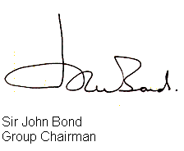



Head Office
HSBC Bangladesh
Anchor Tower, Sonargaon Road
Dhaka
3. THE HONGKONG AND SHANGHAI BANKING CORPORATION LIMITED (HSBC)

3.1 INTRODUCTION
Headquartered in London, HSBC Holdings plc is one of the largest banking and financial services organizations in the world. It began operations in Hong Kong more than 130 years ago. The HSBC Group's international network comprises some 7,000 offices in 81 countries and territories in Europe, the Asia-Pacific region, the Americas, the Middle East and Africa.
With listings on the London, Hong Kong, New York and Paris stock exchanges, around 190,000 shareholders in some 100 countries and territories hold shares in HSBC Holdings plc. The shares are traded on the New York Stock Exchange in the form of American Depository Receipts.
Through a global network linked by advanced technology, including a rapidly growing e-commerce capability, HSBC provides a comprehensive range of financial services: personal, commercial, corporate, investment and private banking; trade services; cash management; treasury and capital markets services; insurance; consumer and business finance; pension and investment fund management; trustee services; and securities and custody services.

3.2 HSBC GROUP AT A GLANCE

Assets US$ 746,335 million at 30 June 2002.

Profit (pre-tax) US$ 5,067 in 2002.

Staff Some 170,000 employees in 81 countries and territories.

Share listings HSBC Holdings is listed on the London, Hong Kong, New York, and Paris stock exchanges. Trading of the company's shares on the stock exchanges is conducted in London, Hong Kong and Paris in the US$ 0.50 ordinary shares, and in New York in the form of American Depository Shares, each of which represents five ordinary shares.

Technology HSBC maintains one of the world's largest private data communication networks and is reconfiguring its business for the e-age. Its rapidly growing e-commerce capability includes the use of the Internet, PC banking over a private network, interactive TV, and fixed and mobile telephones.
Product range Personal, commercial, corporate, investment and private banking; trade services; cash management; treasury and capital market services; insurance; consumer and business finance; pension and investment fund management; trustee services; and securities and custody services.

Key events The HSBC Group evolved from the Hong Kong and Shanghai Banking Corporation Limited, which was founded in 1865 in Hong Kong with offices in Shanghai and London and an agency in San Francisco. The Group expanded primarily through offices established in the bank's name until the mid-1950s when it began to create or acquire subsidiaries. This strategy culminated in 1992 with one of the largest bank acquisitions in history when HSBC Holdings acquired Midland Bank plc (now called HSBC Bank plc), which was founded in UK in 1836.

3.3 FOUNDATION & GROWTH OF HSBC:
The HSBC Group is named after its founding member, The Hong Kong and Shanghai Banking Corporation Limited (HSBC), which was established in 1865 in Hong Kong and Shanghai to finance the growing trade between China and Europe. The inspiration behind the founding of the bank was Thomas Sutherland, a Scot who was then working as the Hong Kong Superintendent of the Peninsular and Oriental Steam Navigation Company. He realized that there was considerable demand for local banking facilities both in Hong Kong and along the China coast and he helped to establish the bank in March 1865. Then, as now, the bank's headquarters were at 1 Queen's Road Central in Hong Kong and a branch was opened one month later in Shanghai.
Throughout the late nineteenth and the early twentieth centuries, the bank established a network of agencies and branches based mainly in China and South East Asia but also with representation in the Indian sub-continent, Japan, Europe and North America. In many of its branches the bank was the pioneer of modern banking practices. From the outset, trade finance was a strong feature of the bank's business with bullion, exchange and merchant banking also playing an important part. Additionally, the bank issued notes in many countries throughout the Far East.
During the Second World War the bank was forced to close many branches and its head office was temporarily moved to London. However, after the war the bank played a key role in the reconstruction of the Hong Kong economy and began to further diversify the geographical spread of the bank. The group expanded primarily through offices established in the banks name until the mid 1950s when it began to create or acquire subsidiaries. This strategy culminated in 1992 with one of the largest bank acquisitions in history when HSBC holdings acquired Midland Bank plc, which was founded in UK in 1836. The following are some key developments in the group since 1955:
1955 The Hong Kong and Shanghai Banking Corporation of California was founded.
1959 The Hong Kong and Shanghai Banking Corporation acquires The British Bank of the Middle East (formerly the Imperial Bank of Persia, now called HSBC Bank Middle East) and The Mercantile Bank (originally the Chartered Mercantile Bank of India, London & China).

1960 Wayfoong Finance Limited, a Hong Kong hire-purchase and personal finance subsidiary, is established.

1965 The Hong Kong and Shanghai Banking Corporation acquires a majority shareholding in Hang Seng Bank Limited, now the second-largest bank incorporated in Hong Kong.

- Midland Bank purchases a one-third share in the parent of London Merchant bank Samuel Montagu & Co. Limited (soon to be renamed HSBC Republic Bank (UK) Limited).

1971 The Cyprus Popular Bank Limited (now Laiki Bank) becomes an associated company of the Group.

1972 The Hong Kong and Shanghai Banking Corporation forms merchant banking subsidiary, Wardley Limited (now called HSBC Investment Bank Asia Limited). Midland Bank acquires a shareholding in UBAF Bank Limited (now known as British Arab Commercial Bank Limitd).
1974 Samuel Montagu becomes a wholly owned subsidiary of Midland.

1978 The Saudi British Bank is established under local control to take over The British Bank of the Middle East's branches in Saudi Arabia.

1980 The Hongkong and Shanghai Banking Corporation acquires 51% of New York State's Marine Midland Bank, N.A. (now called HSBC Bank USA), with a controlling interest in Concord Leasing. UK-based merchant bank Antony Gibbs becomes a wholly owned subsidiary. Midland acquires a controlling interest in leading German private bank Trinkaus & Burkhardt KgaA (now HSBC Trinkaus & Burkhardt KgaA).

1981 Hongkong Bank of Canada (Now HSBC Bank Canada) is established in Vancouver. The Group acquires a controlling interest in Equator Holdings Limited.

1982 Egyptian British Bank S.A.E. is formed, with the Group holding a 40% interest.
1983 Marine Midland Bank acquires Carroll McEntee & McGinley (now HSBC Securities (USA) Inc.), a New York based primary dealer in US government securities.

1985 New Head office building opened at Hong Kong.

1986 The Hong Kong and Shanghai Banking Corporation establishes Hong Kong Bank of Australia Limited (now HSBC Bank Australia Limited) and acquires James Capel & Co. Limited, a leading London-based international securities company.

1987 The Hong Kong and Shanghai Banking Corporation acquires the remaining shares of Marine Midland and a 14.9% equity interest in Midland Bank.

1989 A strategic alliance is entered into between The Hong Kong and Shanghai Banking Corporation and California-based Wells Fargo Bank. Midland Bank Launches First Direct, the UK's first 24-hour telephone banking service.

- HSBC Holdings is established; its shares are traded on the London and Hong Kong stock exchanges.

- HSBC Holdings purchases the remaining equity in Midland Bank. HSBC Investment Bank plc is formed.

- The HSBC Group's Head Office moves to London. Forward Trust Group Limited (now HSBC Asset Finance (UK) Limited), a Midland subsidiary, acquires Swan National Leasing, establishing the UK's third largest vehicle contract hire company.

- The Hong Kong and Shanghai Banking Corporation is the first foreign bank to incorporate locally in Malaysia, forming Hong Kong Bank Malaysia Berhad (now HSBC Bank Malaysia Berhad).

- Wells Fargo & Co. and HSBC Holdings establish Wells Fargo HSBC Trade Bank, N.A. in California to provide customers of both companies with trade finance and international banking services.

1997 HSBC Holdings and Wachovia Corporation of the United States form a non-equity alliance to market corporate financial services worldwide. Forward Trust acquires Eversholt (now HSBC Rail (UK) Limited), a rail rolling-stock leasing company and the largest owner of electric trains operating on the UK mainline network. Marine Midland Bank acquires First Federal Savings and Loan Association of Rochester in New York. In Latin America, the Group establishes a new subsidiary in Brazil, Banco HSBC Bamerindus S.A. and completes the acquisition of Roberts 01S.A. de Inversiones in Argentina (now HSBC Argentina Holdings S.A.).

- Shares in HSBC Holdings begin trading on a third stock exchange, New York. HSBC Holdings acquires Republic New York Corporation (now integreted with HSBC USA Inc.) and its sister company Safra Republic Holdings S.A. (now HSBC Republic Holdings (Luxembourg) S.A.). Midland Bank acquires a 70.03% interest in Mid-Med Bank p.l.c. (Now called HSBC Bank Malta p.l.c.), Malta's largest commercial bank.

2000 HSBC and Merrill Lynch form a joint venture to launch the first international online banking and investment services company. HSBC reaches an agreement in principle to acquire 75% of the issued shares of Bangkok Metropolitan Bank, the eighth largest bank in Thailand. HSBC acquires Credit Commercial de France (CCF), a major French banking group. Shares in HSBC Holdings are listed on a fourth stock exchange, in Paris.

2001 Agreement is reached for HSBC to acquire Barclays Bank’s branches and fund Management Company in Greece. New 44-floor Headquarter building at London’s Canary Wharf is due to be ready for occupation.

3.4 HSBC INTERNATIONAL NETWORK:

The HSBC Group's international network comprises of some 7,000 offices in 81 countries. A brief list is presented below:
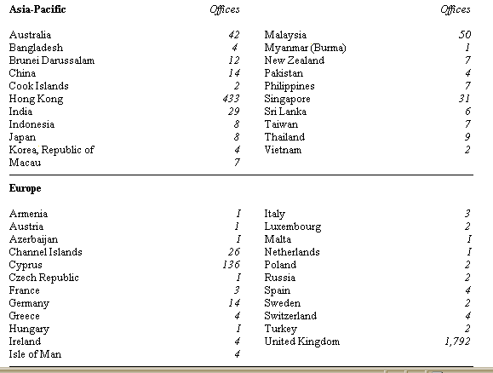

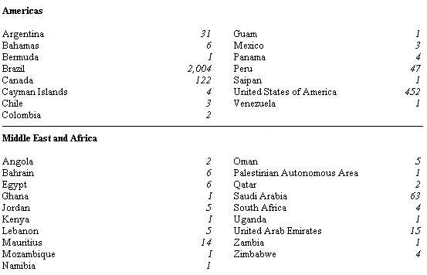
3.5 COUNTRY CLASSIFICATIONS:

To ensure that key resources (management time, capital, Human resources and information technology) are correctly allocated and that the exchange of best practice is accelerated between entities, the group has classified the countries where it operates into 3 categories: the large, the major and the international.

These classifications are a function of sustainable, attributable earnings, the number of retail clients, balance sheet and size of operation. A brief presentation of this classification is shown below:
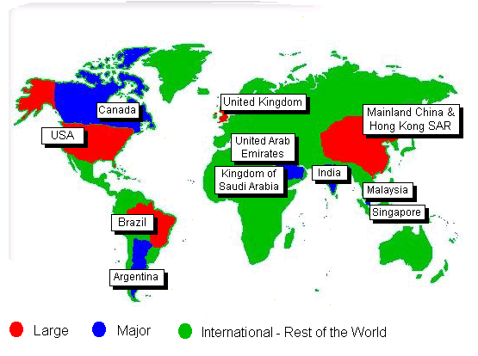
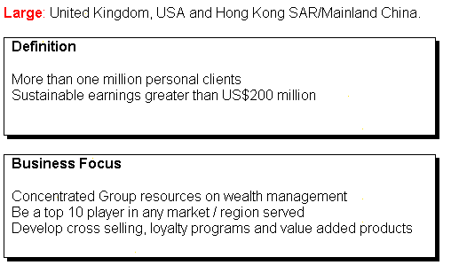

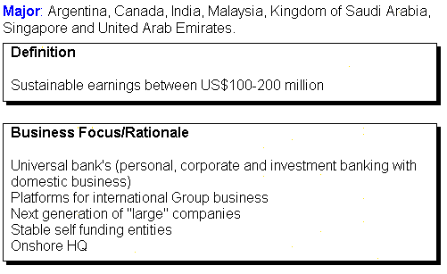

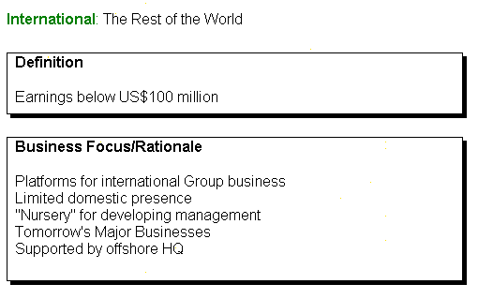
3.6 BOARD OF DIRECTORS:
Sir John Bond, Group Chairman
Age 59. An executive Director since 1990; Group Chief Executive from 1993 to 1998. Joined HSBC in 1961; an executive Director of The Hong Kong and Shanghai Banking Corporation Limited from 1988 to 1992. Chairman of HSBC Bank plc; HSBC USA Inc., HSBC Bank USA and HSBC Bank Middle East and a Director of The Hong Kong and Shanghai Banking Corporation Limited. Chairman of the Institute of International Finance and a Director of Ford Motor Company; A member of the Court of the Bank of England.

The Baroness Dunn, DBE

Deputy Chairman & senior non-executive Director

Sir Brian Moffat, OBE

Deputy Chairman and senior non-executive Director
R Whitson.
Group Chief Executive


The Lord Butler, GCB, CVO

R K F Ch'ien, CBE


W R P Dalton D G Eldon

 D J Flint W K L Fung, OBE

 S K Green S Hintze

 A W Jebson Sir John Kemp-Welch

 The Lord Marshall C Miller Smith

 Sir Mark Moody- Stuart M Murofushi

 C E Reichardt H Sohmen, OBE
 Sir Adrian Swire


C F W De Croisset
3.7 HSBC Principal Business Entities:

The group is represented by different business entities in over 81 countries and territories around the world. It would be difficult to list them all individually so the name of the major entities is shown on the following page along with their region and volume of operation.

3.8 HSBC Group Vision:


3.9 HSBC Group Values:
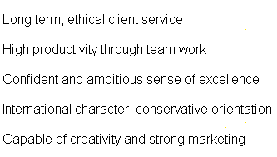

3.10 HSBC Governing Objective:


3.11 HSBC'S BUSINESS PRINCIPLES AND VALUES

The HSBC Group is committed to five Business Principles:
- Outstanding customer service;
- Effective and efficient operations;
- Strong capital liquidity;
- Conservative lending policy;
- Strict expense discipline;

HSBC also operates according to certain Key Business Values:
- The highest personal standards of integrity at all levels;
- Commitment to truth and fair dealing;
- Hand-on management at all levels;
- Openly esteemed commitment to quality and competence;
- A minimum of bureaucracy;
- Fast decisions and implementation;
- Putting the Group's interests ahead of the individual's;
- The appropriate delegation of authority with accountability;
- Fair and objective employer;
- A merit approach to recruitment/selection/promotion;
- A commitment to complying with the spirit and letter of all laws and regulations;
- The promotion of good environmental practice and sustainable development and commitment to the welfare and development of each local community.

3.12 HSBC Brand & Corporate Identity:

The Hexagon logo of HSBC derives from HSBC’s traditional flag, a white rectangle divided diagonally. Like many other Hong Kong company flags in the last century, the design of the flag was based on the cross of ST.Andrew, The Patron Saint of Scotland.

HSBC brand & corporate identity represents what HSBC wants its brand to mean to its customer. It is derived from the groups:

Corporate Character
HSBC is a prudent, cost conscious, ethically grounded, conservative, trustworthy international builder of long-term customer relationships.

Basic Drives
Higher productivity, Team Orientation, Creative Organization & Customer Orientation.

Vision
To be the world’s leading financial company.

The essence of HSBC brand is integrity, trust and excellent customer service. It gives confidence to customers, value to investors & comfort to colleagues.

3.13 HSBC in Bangladesh:
The HSBC Asia Pacific group represents HSBC in Bangladesh. HSBC opened it’s first branch in Dhaka in 17th December, 1996 to provide personal banking services, trade and corporate services, and custody services. The Bank was awarded ISO9002 accreditation for its personal and business banking services, which cover trade services, securities and safe custody, corporate banking, Hexagon and all personal banking. This ISO9002 designation is the first of its kind for a bank in Bangladesh. The Hong Kong and Shanghai Banking Corporation Bangladesh Ltd. primarily limited its operations to help garments industry and to commercial banking. Latter, it is extended to pharmaceuticals, jute and consumer products. Other services include cash management, treasury, securities, and custodial service.

Realizing the huge potential and growth in personal banking industry in Bangladesh, HSBC extended its operation to the personal banking sector in Bangladesh and within a very short span of time it was able to build up a huge client base. Extending its operation further, HSBC opened a branch at Chittagong, three branch offices at Dhaka (Gulshan, Motijheel and Dhanmondi) and an offshore banking unit on November 1998. At 30 June 2003, the number of employees of this bank in Bangladesh was 257.

In 2002, paid-up capital of this bank was BDT 380 million. Deposit of this bank was BDT4,980 million. Among this deposit, called deposit was BDT 487 million and fixed deposit was BDT 1,323 million. The amount of advance and investment was BDT 1,180 million and BDT 100 million respectively. In 2002, this bank operated foreign exchange business of BDT 8,234 million.
HSBC Bangladesh is under strict supervision of HSBC Asia Pacific Group, Hong Kong. The Chief Executive Officer of HSBC Bangladesh manages the whole banking operation of HSBC in Bangladesh. Under the CEO there are heads of departments who manage specific banking functions e.g. Personal banking, corporate banking, etc.

Currently HSBC Bangladesh is providing a wide range of services both two individual and corporate level customers. In the year 2000, the bank launched a wide array of personal banking products designed for all kinds of (middle and higher-middle income) individual customers. Some such products were Personal loans, car loans, etc. Recently the bank launched three of its personal banking products – Tax loan, Personal secured loan & Automated Tele Banking (ATB) service. These products are designed to meet the diverse customer needs more completely.

HSBC in Bangladesh also specializes in self-service banking through providing 24-hour ATM services. Recently it has introduced Day & Night banking by installing Easy-pay machines in Banani, Uttara and Dhanmondi to better satisfy the needs of both customers and non-customers. In total HSBC currently has 9 ATM’s (5 on-site & 4 offsite) and 3 Easy-pay machines located at various geographical areas of Dhaka & Chittagong.
3.14 HSBC BANGLADESH AT A GLANCE:

Name of the Organization: The Hong Kong Shanghai Banking Corporation Bangladesh LTD

Year of Establishment: 1996

Head Office: Anchor Tower, 1/1-B Sonargaon Road
Dhaka 1205, Bangladesh

Nature of the organization: Multinational company with subsidiary group in Bangladesh.

Capital: Paid up capital: TK 4380 million
Deposit – Tk 4,980 million
Advance – Tk 3,255 million

Shareholders: HSBC group shareholders

Products: Savings & deposit services.
Loan products.
Corporate and Institutional services.
Trade services
Hexagon
Management: Mr. David J Griffits
Chief Executive Officer

Mr. Wasim Adnan Wahed
Chief Operating Officer

Mr. Mamoon M Shah
Manager, Personal Financial Services

Mr. Adil Islam
Head of Corporate Banking

Mr. Syed A H Uddin

Manager, Human Resources

Mr. Munir Hussain Manager, Marketing

Number of Offices: 5 (Dhaka, Motijheel, Gulshan, Dhanmondi & Chittagong)
Number of ATM’s: 9

Number of Easy Pay
Machines: 3

Number of employees: 257

Technology: Offers full online banking from branch to branch and also from Dhaka to Chittagong.

Service Coverage &
Customers: Serves individual and corporate customers within Dhaka & Chittagong.
3.15 HSBC Bangladesh Offices & ATM Centers:

HSBC Bangladesh currently provides services from two of it’s full service branches one in Dhaka and the other one in Chittagong. Besides these offices there are three personal banking Booth offices located at Gulshan, Motijheel and Dhanmondi. There is currently 8 ATM’s operating in Dhaka and 1 in Chittagong. The list of these offices is shown below along with there their addresses:

Branches & Booths:
- Dhaka Main Office (Full service branch with one ATM)
Anchor Tower, Sonargaon Road - Dhaka
- Gulshan Office (Personal Banking Booth with one ATM)
Gulshan Avenue, Dhaka
- Motijheel Office (Personal Banking & Remittance office with 1 ATM)
Rajuk Avenue, Motijheel- Dhaka
- Dhanmondi Office (Personal Banking Booth with one ATM)
Road-27, Dhanmondi-Dhaka
- Chittagong Office (Full service branch with one ATM)
Osman Court, Agrabad – Chittagong

Offsite ATMs:
- Uttara model town, Uttara - Dhaka
- Mumtaz plaza, Dhanmondi - Dhaha
- Kemal Ataturk Avenue, Banani - Dhaka
- Concord Twin Towers, Shantinagar – Dhaka

3.16 Organizational Hierarchy At HSBC, Bangladesh:
HSBC follows a 4 layer management philosophy in Bangladesh. These are Managers, Executives, Officers & Assistant officers. The CEO is the top most authority of all the levels. Managers are the departmental heads who are responsible for the activities of their departments. They are the heads of the department and formulate strategies for that department. e.g. Human Resources Manger. Executives have the authority next to managers. They are basically responsible for certain activities & organizational functions. e.g. Admin Executive. These two layers represent the management level of HSBC Bangladesh.
Officers are the next persons to stand in the hierarchy list. They are the typical mid-level employees of HSBC organizational hierarchy. These officers are responsible for managing the operational activities and operating level employees. The operating level employees of HSBC who are ranked as Assistant Officer fill the last layer of this hierarchy. They perform they day-to-day operational activities of HSBC. An organizational hierarchy chart is shown below:
Managers
Executives
Officers
Assistant Officers
3.17 ORGANIZATIONAL STRUCTURE OF HSBC Bangladesh:

3.17.1 Chief Executive Committee:
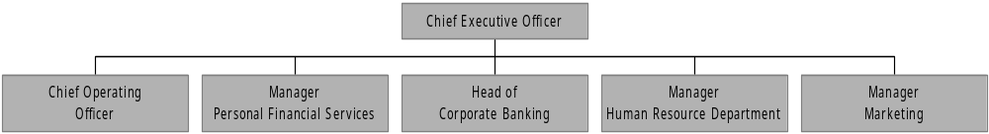

The organizational structure of HSBC Bangladesh is designed according to the various service and functional departments. The Chief Executive Officer (CEO) heads the chief executive committee, which decides on all the strategic aspect of HSBC. The CEO is the person who supervises the heads of all the departments and also is the ultimate authority of HSBC Bangladesh. He is responsible for the all the activities of HSBC Bangladesh and all its consequences. He administers all the functional departments and communicates with the department heads for smooth functioning of the organization. The HSBC Chief Executive Committee is formed with the heads of all departments along with the CEO. The structure of this top-most authority is shown in the figure above. Besides the CEO the CEC is staffed with 5 more managers: Chief Operating Officer, Manager Personal Financial Services Head of Corporate Banking, Manager Human Resource Department and Manager Marketing.
3.18 Functional Departments of HSBC:
HSBC activities are performed through functional departmentalization. So, the departments are separated according to the functions they perform (HR, Marketing, Personal Banking, etc.). There are 6 major functional departments at HSBC: Human Resources, Services, Financial Control, Personal Banking, Corporate Banking and Marketing. Within these major departments there are some other subsidiary departments that allow smooth operation of their own major departmental function. A graphical presentation of all the departments (Major & minor) is shown in the following page. A brief functional description of these departments is discussed below:

Functional Departments of HSBC
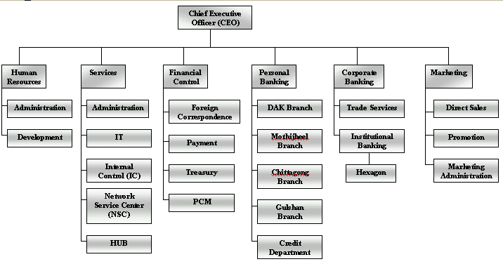

___________
IT – Information Technology
PCM – Payment and cash management
HUB – HSBC universal Banking
3.18.1 Human Resource Department:
The Human resource Manager heads this department. The major functions of this department are Recruitment, Training and developments, Personnel Services and Security. The HR department is much concerned with the discipline that is set up by the HSBC group. HSBC group has got strict rules and regulations for each and every aspect of banking, even for non-banking purposes; i.e. The Dress Code. All these major personnel functions are integrated in the best possible way at HSBC, which results in its higher productivity. The Human resource officer monitors the employee staffing and administration activities. The Training officer supervises Training, development & rotation activities. The structure of the HR department is shown below:
Structure of Human Resource Department

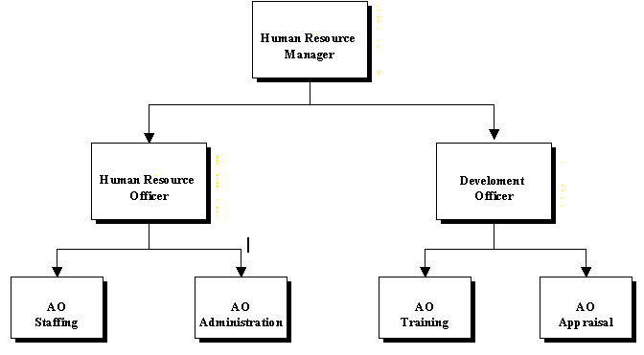

AO = Assistant Officer
3.18.1.1 Recruitment, Training and Development:

HSBC Bangladesh limited follows a standard procedure for recruitment and selection. However there is no set time period when this recruitment and selection takes place. Each Departmental head places the requisition for recruitment to the Human resource officer, if any vacancy is created due to (1) Retirement, (2) Resignation (3) Death, or (4) Extra work load.

The process for the recruitment of personnel for managerial and non-managerial level differs slightly but the basic steps are same in both the cases. The steps are-

Step- I Initial Screening:
Step- II Screening by Departmental Heads:
Step- III Filling of the HSBC Job Application Form (HJAF)
Step- IV Screening on the basis of SAF:
Step- V Initial Interview
Step –VI Selection for written test
Step- VII Written test
Step –VIII Evaluation of test papers
Step –IX Selection of Final interviewees
Step –X Final interview
Step- XI Documentation Check
Step – XII Medical Examination
Step – XIII Probationary Appointment:
Step- XIV Confirmation
In order to enhance the efficiency of the employees, HSBC gives emphasis on the both theoretical and practical training for its personnel. All the training and development programs are aimed at two basic reasons - (1) skill development (2) motivation through counseling and persuasion to change value system. For the top management or senior Managers there is provision for overseeing training arranged by HSBC group. For the mid-level manager or other managerial level there is provision for regional training courses. Besides, for non-management level there are training programs arranged in different institution and also with in the organization. For the operatives, various on the job-training program are conducted within the company. Finally, HSBC follows a performance based promotion system for all levels of its employees.

3.18.1.2 Performance Appraisal

The company follows both rating and descriptive systems for the performance appraisal. Although the appraisal system is non-participative but the employees are annually assessed with a joint consultation with their immediate supervisor and departmental head.

Rating is mainly done on the following factors-
i) Knowledge of work
ii) Accuracy and Reliability
- Speed
- General intelligence
- Sense of responsibility and duty
- Diligence
- Initiative and self confidence
- Readiness to work for and with others.

3.18.1.3 Welfare Activities:
HSBC has many well-structured welfare policies for its employees. These include well-structured wage & salary policy, medical facility, sports & cultural facilities, provision for loans at a minimal rate, free uniform etc. These welfare policies aim at strengthening the relationship of the employees to the organizations and make them more responsible in their respective positions.

3.18.2 Services Department:
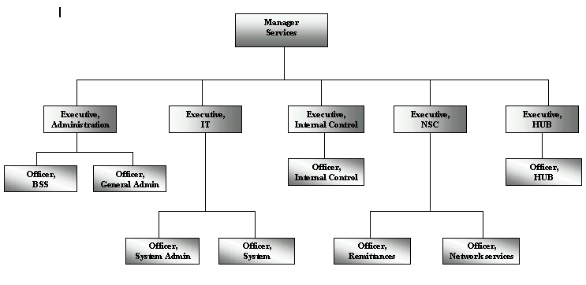
This is an integral and vital part of the bank. The services department ensures smooth operation and functioning within and between all the departments of HSBC. It also provides continuous support to the core banking activities of HSBC. The Manager of Services heads this department who formulates and manages various critical issues of the services function of HSBC. He is followed by a group of executives who are the heads of various subsidiary divisions that operate within the services department. The services department is considered as the backbone of all other departments. The various subsidiary division within this department are Administration, IT, Internal Control (IC), Network Services Center (NSC), and HUB. A structure of the services department is presented below followed by a briefing of the subsidiary divisions:

3.18.2.1 ADMINISTRATION:
Like that of any other organizations, the Admin department of HSBC makes sure that the organizations moves on with all its departments and staffs operating according to all the rules and regulations of the company. It also prevents any bottlenecks within the work process and ensures smooth functioning. The admin department has two divisions – general administration and Business support services.
The general admin division is pretty much similar to the admin departments of other companies that ensure discipline and regulatory concerns. The business support services provide supports to the departments during employee leaves and sudden terminations so that the department can function without problems.

3.18.2.1 IT
This department gives the software and hardware supports to different departments of the bank. As HSBC is engaged in online banking, the role of IT is very crucial for the bank. This department is the most active department of HSBC where employees always stand by to solve any problems in the system. The managers and executives of IT division work continuously to develop the total IT system of HSBC so that it can be operated with ease, accuracy and speed.

3.18.2.3 INTERNAL CONTROL:
HSBC has internal auditors who visit on regular basis and submit the report to the higher authority for audit purposes. This gives different departments the chance to know their mistakes and take necessary corrective actions. Again, the Bank annually administers a company wide audit program to evaluate the overall performance of the bank in Bangladesh.
3.18.2.4 HSBC Universal Banking (HUB):
The HSBC banking system is called HUB. HSBC does the online banking and it is HUB, which sets up the parameter for that. This HUB is linked with the HSBC group via satellite and each and every transaction made by HSBC within Bangladesh is being recorded at the HSBC Asia-pacific headquarters at Hong Kong via HUB. Thus the HUB is the most powerful and important equipment of HSBC Bangladesh that monitors and tracks any fraud and faults made with HSBC Bangladesh.

3.18.2.5 NETWORK SERVICES CENTRE (NSC):
This department can be described as the ‘Power House of HSBC Bangladesh. NSC does the back office job for the bank. The main four jobs that are performed by NSC are Clearing, Scanning of signature cards, issuing checkbooks and sending & receiving Remittances. NSC looks after the clearing process of HSBC and makes necessary contact with the central bank for maintaining account flows. All the customer signatures are scanned in this department and are entered into the system. NSC also issues checkbook for new and old accounts based on requisition from various branches. ‘Remittance’ is a banking term, which means ‘Transfer of funds through banks’. When a bank remits on behalf of its customers, it is termed as outward remittance. On the other hand, when the bank receives the remittance on behalf of the bank, it is inward remittance. The following are the methods that NSC used to remit money for customers: Telegraphic Transfer (TT), Demand Draft (DD) & Cashier’s Order.

3.18.3 Financial Control Department (FCD):
This is considered as the most powerful department of HSBC. It keeps tracks of each and every transaction made within HSBC Bangladesh. It is headed by Manager of FCD who ensures that all the transactions are made according to rules and regulation of HSBC group. Violation of such rules can bring serious consequences for the lawbreaker. The functions of FCD are briefly discussed below along with an organ gram of the department:
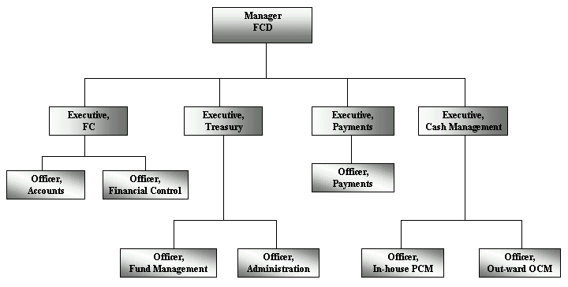

---
FC – Foreign Correspondence
PCM – Payment & cash management
OCM – Outward cash management

3.18.3.1 Foreign Correspondence (FC):
FC keeps records of all the accounts of HSBC. All the vouchers, notes, advices and transaction reports of the branches are sent to FC for record keeping purposes. FC also prepares the financial statements for the banks and decided upon banks assets and liabilities. It also deals with the returns that are submitted to the Central Bank on regular interval.

3.18.3.2 Treasury:

This department works under FCD. Their main job is to take decisions regarding purchase and sell of foreign Currency. The purpose of Treasury's operations is to utilize the funds effectively and arrange funds at a lowest possible rate of interest, through maintaining effective relationship with other banks and following the Government rules and foreign exchange regulations

3.18.3.3 Payment and cash Management (PCM):
PCM deals with the inter-bank payment. PCM strategies are designed to ensure efficiency, profitably and comprehensive support.

3.18.4 Personal Banking Division (PLB):
PLB is the most flourishing department of HSBC Bangladesh. This department basically deals with the management of products and services offered to the in individual consumers. Within a span of only seven years, HSBC PLB has grown tremendously and is still growing with its innovative products and service offerings. Manager of PLB, Mr. Mamoon M Shah, manages this department. He is the person behind the astounding growth of PLB department in HSBC Bangladesh. Chief of PLB manages and supervises the Personal Banking activities of the branch network of HSBC Bangladesh. The 5 branches of HSBC basically deal with the personal banking activities and provide various accounts services to individual customers.

3.18.4.1 Branch network:
There are five branches of HSBC, 4 situated at different Dhaka and 1 at Chittagong. Only the Dhaka office (head office) branch & Chittagong branch deals with both corporate and personal banking. The other 3 offices only deal with the personal banking activities. There functions are to provide various financial services to the consumers. These include customer services, sale of various PLB products, opening new accounts, providing cash, remittance and other teller services, etc. the branches are quite decentralized for better delivery of services to customer and have their own premises and facilities. These branches are headed by branch managers. Each branch is staffed with its own team of employees. A great deal of teamwork is seen within these branches. ATM’s are situated with each branch premises.

3.18.4.2 Credit Department:
The personal banking credit department deals with the consumer credit schemes such as the Personal loan, car loan, personal secured loan, personal secured credit etc. which are tailored to meet the demand of individual customers. The manager of PLB credit, Mr. Fuad Yusuf Khan, approves and administers all the activities of this department. He is staffed with two loan approval officers, two loan processing officer, two assistant officers and one MIS clerk. The approval officers mainly reject or approve the credit requests. After being checked by the approval officers, the credit requests go to the processing officers for further processing of the application.

3.18.4.3 ATM Center:
The ATM center ensures smooth operation of the ATM machines that are located at Dhaka and Chittagong. The ATM center is responsible for regular replenishment of the off-site ATM’s and servicing of all the ATMs. Currently a total 9 ATMs are in operation. The ATM center also deals with issuance, termination and servicing of the ATM cards. Basically, the ATM center is the department that is solely responsible for all the activities related to ATM and is the facilitating department that enables customers 24 hour banking support.

3.18.4.4 ATB center:
ATB refers to Automated Tele Banking. This department deals with the back office servicing of the HSBC phone banking services provided to customers. This department is basically responsible for the activation of ATB, ATB pin generation, and ATB security management, ATB blocking and troubleshooting of all ATB problems. Currently this department is staffed with one executive and an officer
3.18.5 Corporate Banking:
This division of HSBC provides financial services to organizational clients. HSBC is a worldwide leader in banking and financial services whose success is based on its relationships with its corporate clients. Whether it is locally or around the world, HSBC offers a comprehensive range of services that can be tailored to the individual needs of the company. Mr. Adil Islam, who manages the activities of corporate banking of HSBC BANGLADESH, heads the department. Two offices of HSBC Bangladesh offer corporate banking services to corporate clients. These are the Dhaka Head Office and Chittagong office. Corporate Banking of HSBC Bangladesh includes Corporate Institutional Banking (CIB) Trade Service (HTV), and Hexagon. These sub-divisions are discussed briefly in the following sections:

3.18.5.1 Corporate Institutional Banking (CIB):
As their major customers operate internationally, HSBC serves them internationally. Operating through the major centers and in close liaison with HSBC Investment Bank, Corporate and Institutional Banking provides the full range of the Group's capabilities at local and global levels, with a particular focus on payments and cash management, trade and securities custody. HSBC also offers local financial institutions and banks access to wide range of financial services available on an international basis. The services are tailored to suit the needs of the companies. CIB has two separate wings: Relationship management department and Hexagon. These are discussed below:

3.18.5.2 Relationship Management Department:
The RM department consists of various relationship managers who are assigned to different corporate client to better satisfy their needs. These RM’s communicate with the clients and are solely responsible for the companies they deal in. Any information regarding a corporate client must be communicated through the respective RM assigned to that corporate client. A relationship manager may be assigned more than one company and this decision depends on the Head of Corporate Banking.

3.18.5.3 HEXAGON:
The Hexagon department deals with all aspects related to HSBC’s unique banking software product - Hexagon. It is the global Electronic Banking system of HSBC, which offers the customers more convenient and efficient banking than ever before. It is an innovative desktop banking system developed by the HSBC group, which operates via the group’s proprietary worldwide communications network.

3.18.5.4 HSBC TRADE SERVICES (HTV)

Trade service is known by various names in other banks, e.g. Trade Finance Foreign Exchange, Foreign Trade etc. However, the functions are the same. As the name suggests, this department is involved in facilitating trade, both international & within Bangladesh. HSBC is the leading provider of trade finance and related services to importers and exporters in Asia. Trade is considered a core business of the group. The group’s presence in 81 countries of the world gives a good opportunity to control both ends of a trade transaction and keep the business within the Group. The various awards it has won from the leading publications of the world acknowledge HSBC’s excellence in trade. The trade service department has two separate subsidiaries: Credit Administration & Foreign Exchange Division.

Credit Administration department basically deals with all the documentation, processing, administration and disbursement of the import-export services provided to corporate clients. This department is known to be the heart of HSBC trade services that administers and manages all the trade tools and facilities provided by HSBC Corporate Banking. Some important aspects of this department are LC advising, documentation, OD facilities, guarantees, etc.

The For-ex division of trade services is solely concerned with the management of Foreign exchange inflow and outflow. The For-ex division of trade service in relation with NSC and FCD manages the foreign currency traffic of HSBC that originates from Corporate Banking and trade services.

3.18.6 Marketing Department:
The sixth major department of HSBC is the marketing department. The marketing department of HSBC play a vital role in fostering the continuos growth HSBC in Bangladesh. A manager is assigned to this department who looks after the overall marketing operation of HSBC in Bangladesh. This department is basically concerned about marketing the company’s products, services and building a strong corporate image. The marketing department of HSBC has three subdivisions: Direct Sales, Promotion & Marketing Administration. This division are discussed below:
3.18.6.1 Direct Sales (DS):
An executive is assigned to this part of the marketing department. The Direct Sales division coordinate & manages the sales activities of all the Mobile sales officers (MSO) of HSBC Bangladesh. The MSO’s basically makes sales of the company various Personal Banking products such as, savings accounts, consumer loan, etc outside the banking premises. There are a total of more than 75 mobile sales officers (MSO) employed in the cities of Dhaka and Chittagong. The MSO’s are assigned to specific branches for making sales activities more smoothly. The DS executive sets sales strategies & targets for the Sales officers and manages the whole team of MSO’s in Bangladesh. The direct sales department also decides upon the commission and remuneration of the mobile sales officers as their salary structure is based on sales performances. Thus this part of the marketing division is very important for the overall growth of the Personal Banking Division.

3.18.6.2 Promotion:
This part of the marketing department deals with all the promotional activities of HSBC Bangladesh. Prime responsibilities of this department are: Maintaining strong public relations with various media intermediaries, Advertising the companies products and services, building a strong corporate image of HSBC in Bangladesh.

3.18.6.3 Public Relations:
The promotion department organizes various environmental and social activities in order to build a strong corporate image of HSBC in the minds of customers as well as in the media. Maintaining strong relationship with news media is another major duty of this department.

3.18.6.4 Advertising:
The promotion also coordinates all the advertising of HSBC products within Bangladesh. Some of the advertising tools that are frequently used by the company are as follows:
- Newspapers Advertising: Regular advertisements of various products and services of HSBC are given in some of the countries most renowned daily newspapers.
- Billboards: Huge colourful billboards with HSBC logo are found in various major areas of Dhaka and Chittagong. These billboards emphasize on the needs of customers and shows HSBC logo as solution to their needs.
- Road Side Signposts: Medium sized multi colour signposts focusing on various products of HSBC are found on the roadsides of various posh areas such as, Gulshan, Dhanmondi, Baridhara, Motijheel, etc.
- Mailers: various product updates and new product information are regularly sent to existing customers of HSBC.
- Brochures: Various colourful brochures featuring specific products of HSBC are being displayed and distributed to existing and potential customers via branch offices and Mobile sales officers.
These are some of the promotional activities managed and coordinated by the promotion department.

3.18.6.5 Marketing administration:
This department formulates & executes various marketing strategies of HSBC Bangladesh. This department also administers various marketing research activities on the existing and potential customers of HSBC. Some such research activities are: mystery shopping, critical incident surveys, customer suggestion surveys, etc. The results of these surveys are integrated while formulating various marketing strategies. This department also deals with the billing and invoicing of various marketing & advertising costs of HSBC Bangladesh.

In these are the major departments of HSBC Bangladesh. Except the branches all other departments are situated at HSBC Bangladesh head offices located at Anchor Tower, Kawran Bazar. Most of HSBC’s operation and activities are operated centrally from the head office. But to deal with customers more completely, the branches are given considerable authority and they operate in a more decentralized manner but subject to verification of the respective departments.
3.19 PRODUCTS & SERVICES

HSBC Bangladesh carries out all traditional functions, which a commercial Bank performs such as Mobilization of deposit, disbursement of loan, investment of funds, financing export & import business, trade & commerce & so on. Besides it also offers some specialized services to its customers. Products & services offered by HSBC can be categorized according to the customers they serve. Thus two major groups can be identified. They are – individual customers or consumers & corporate customers or organizations. An in-depth analysis of HSBC’s product and services in Bangladesh is presented in this section. First of all, the liability products of the bank are discussed. Then, the various products and services of personal banking division will be presented. The summary of all the products and services of HSBC Bangladesh is displayed in the following page with the help of a diagram.

3.19.1 Products & Services: Liabilities

The financial products of HSBC can be categorized into two groups – Asset products and liability products. Asset products are the various types of credit and loan schemes offered to consumers whereas the liability products consist of all the savings and deposit schemes offered to customers. In the following section, the liability products of HSBC are described briefly:

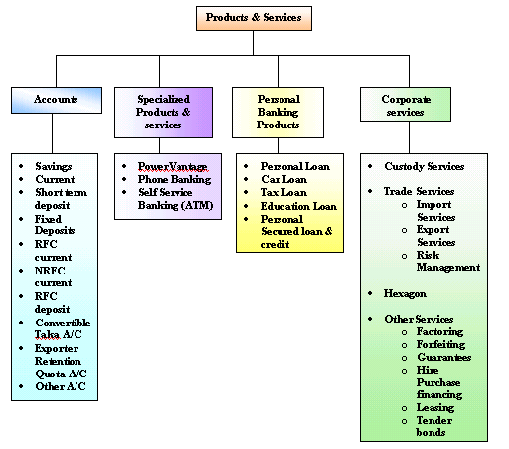

3.19.1.1 Savings Account:
This is a depository account basically designed for small-scale savers. This is an interest bearing account and the features of this account are as follows:
- Opening balance Tk 50,000
- Average balance that should be maintained: Tk 50,000
- Interest bearing (from 4.25% - 5.25%). One of the unique features of HSBC savings account is that interest is calculated on daily outstanding balance and is credit to customers account every six months.
- No restrictions on number of Transactions
- No yearly ledger fee
- Free ATM card and phone banking service
- Documentation required to open the account: one pp-size photograph, filled account opening form, passport copy & check/cash of Tk 50,000/
- Can be opened only by Bangladesh and dual citizens in single or joint names.

3.19.1.2 Current Account:
This is a also a depository account basically designed for various customers. This is a non interest bearing account and the features of this account are as follows:
- Opening balance Tk 50,000
- Average balance that should be maintained: Tk 50,000
- No restrictions on number of Transactions
- No yearly ledger fee
- Non interest bearing
- Free ATM card and phone banking service
- Can be opened only by:
  - Individuals (joint or single)
  - Proprietorship companies
  - Partnership companies
  - Limited Companies
  - Liason offices
  - NGO’s
- Documentation needed: various kinds of documents are needed for the companies such as memorandum of association, board resolution, etc. however the requirements for individuals are same as the savings account.

3.19.1.3 Short term deposit (STD):
These accounts are opened mostly by the organizations. Organizations normally maintain current accounts in the banks. They need to transact bulk amount regularly that’s why, current account fits with their requirements. As current accounts do not provide any interests and as the organizations cannot have savings account, they are deprived of earning any interest despite having huge deposit in their accounts. ‘Short-term deposit’ accounts enable them to earn interests from their accounts. These kinds of accounts share some properties of both current and savings accounts. The account provides interests which are like the savings accounts and the holder can withdraw any amount any time from his account which is a property of the current account. Individuals especially, businessmen maintain such accounts.
3.19.1.4 Fixed Deposit:
It is also known as term deposits. These deposits are made in the bank for a fixed period of time. This period of time should be specified in advance. The bank needs not maintain cash reserves against these deposits & therefore, it offers interest rates that are higher than the savings accounts.

3.19.1.5 Residents Foreign Currency Current accounts:
BD nationals residing abroad open this account. Foreign nationals residing abroad or in Bangladesh, Foreign firms registered abroad, Bangladeshis working in multinationals at Bangladesh and receiving salary in FC can also open such account. The account is non-interest bearing and there are various kinds of restrictions for withdrawals and deposits. The account can be maintained in Euro (EUR), Pound Sterling (GBP) and US Dollar (USD).

3.19.1.6 Non-resident foreign currency accounts:
These are time deposit interest bearing accounts. They can be opened by all non-resident Bangladeshi nationals, persons having dual citizenship, shipping staffs, etc. they can be maintained in EUR, GBP & USD currencies. These accounts are strictly monitored by the central bank and restrictions exist for these accounts.

3.19.1.7 Resident foreign currency deposit accounts
Balances in these accounts are freely transferable abroad without any restriction from Bangladesh bank. Resident Bangladeshis returning from abroad can open this account within one month of his/her return.
3.19.1.8 Convertible Taka account;
Diplomatic missions, UN organizations, non-profit international companies, foreign contractors & consultants, expatriate resident employees of UN missions can open these accounts. These accounts are maintained in Tk. and are non-interest bearing.

3.19.1.9 Exporters Retention quota accounts:
Exporters earn foreign currency. But due to legal restriction posed by the Bangladesh bank, they cannot keep foreign currency more that $5,000. As the exporters earn bulk of foreign exchange and are deprived of the benefits of foreign currency accounts, a special kind of account is created to benefit them. In this special type of account they can keep up to a 7% of their total amount of foreign currency exports and earn interests according to dollar interest rates. Some other special benefits are also awarded to such customer such as free endorsements, withdrawals that are higher than the maximum limits, discounted rates for TC’s, etc. They use those accounts in the purpose of remittance and other business purposes.

3.19.1.10 Other accounts:
There are various other accounts that are created to meet customer demands and requirement. Such accounts are customized and restrictions on these accounts are subject to change.

Services offered to these accounts:
Wide ranges of services are offered to the customers who hold these accounts. Some such services are:
- Free ATM Card, check book & phone banking service
- Cheques/cash deposits
- Standing instruction
- Quarterly/monthly statement of account
- Foreign currency Endorsement against travel quota and sale of Travelers cheques (Thomas Cook).
- Issue of Solvency/Bank certificate
- Payment orders, demand drafts, Telegraphic transfers.
- Inward and outward funds transfer and receiving.

Some unique services are also provided to customers using HSBC accounts. These services are Phone Banking, Self Service Banking & Power vantage Scheme.

3.19.2 Personal Banking Products:
The personal banking division of HSBC has designed various assets products to meet the needs of individual customers. These are various loans and consumer credit schemes that satisfy and fulfill some basic purchase purpose of the individual customers. These products are described in the following sections.

3.19.2.1 Personal Installment Loan (PIL):
- This loan is known as the any-purpose consumer loan of HSBC. This loan is currently the best product of HSBC Bangladesh and is given to HSBC customers. The customers can avail this loan for any of his personal needs such as, traveling, purchase of household goods, computer purchase, etc. Invoices or quotations are not required for these loans, as the bank will disburse the credit amount directly to customers account.

- No Personal guarantee or cash security is required to support the loan. Even no down payment is required to disburse this loan.

- The main feature of the PIL is simplicity. This means by completing very simple and easy documents the customers can apply for the loan.

- Low and very competitive interest rates are offered for this loan with very low processing fee and stamp charges. The interest rate is 19% on reducing balance and 18% for salary account customers.

- Anyone who is at least 25 years old, employed in a well-established company for 2 years with a minimum monthly income of TK 15,000 can apply for the loan. Self-employed individuals can also apply but valid income proof must be presented to the bank.

- The loan amount ranges from Tk50,000 to Tk750,000 or maximum four times of the applicants monthly income, whichever is lower.

- Loan repayments are made in form of equal monthly installments (EMI). The customers have the flexibility of choosing the repayment period (12, 24 or 36 months). The monthly installment is automatically debited from the customers personal account held with HSBC.

- Provisions for partial repayments and early settlement of the loan are also present but the customer has to pay the respective fees of settlement.

- Loans are approved at the sole discretion of HSBC credit authority and rejections are unquestionable.

3.19.2.2 CAR LOAN
- Car loan is provided to HSBC customers to purchase personal cars. This loan is the second best product of HSBC that finances the cost of the car for its customers.

- The scheme covers loans ranging from TK100,000 to Tk5,000,000. The loan amount is up to a maximum of 70% of car value for a reconditioned car and 60% for a new car. The loan does not cover registration, insurance and other costs.

- The customers need to submit quotations from at least 3 vendors mentioning the price of the car to be purchased.

- The loan value is paid to the car vendor in the form of pay order.
- The interest rate on the loan is 15.5% (special offer) with low processing fee and no hidden cost.

- HSBC makes arrangements with selected insurance companies for special discounts on their insurance policies.

- Anyone who is at least 25 years old, employed in a well-established company for 2 years with a minimum monthly income of TK 20,000 can apply for the loan. Self-employed individuals can also apply but valid income proof must be presented to the bank.

- Loan repayments are made in form of equal monthly installments (EMI). The customers have the flexibility of choosing the repayment period (12, 24, 36 & 48 months). The monthly installment is automatically debited from the customers personal account held with HSBC.

3.19.2.3 Personal Secured Loan & Credit

- Personal secured Loan/credit is a credit facility against time deposits or government savings certificates and bonds.
- A customer can get a loan amount up to 90% of the security value.
- A customer can re-invest his money while his/her main investment (certificate or Bonds) remain intact and this enable the customer to have the flexibility to meet short-term commitments as well as long term purchases without unlocking their long term investments.
- For Personal secured credit (short term) the interest is calculated on the daily outstanding loan amount and for personal secured loan (long term) the rate is calculates annually.
- Facilities are repaid when either time deposits are withdrawn or govt. bonds mature.
3.20 HSBC Group & HSBC Bangladesh

The parent company of HSBC Bangladesh is The HSBC Group represented by HSBC Asia Pacific, headquartered at Hong Kong. They are the major shareholders of HSBC Bangladesh. The operations in Bangladesh are under the supervision of HSBC Asia Pacific Region and are managed, regulated, monitored and controlled by them.

The management of HSBC Bangladesh is trained by HSBC Group. All the five top-level managers of HSBC Bangladesh are international managers and have the corporate sense of Management. These top-level managers are appointed by the HSBC group both globally and locally. In case of unusual circumstances, the HSBC Group recruits or appoints managers from around the world to manage specific tasks or activities.

A group of External Auditors appointed by HSBC Asia Pacific annually visits the HSBC Bangladesh offices in order to assess their effectiveness, management, operational efficiency, discipline, rules and regulation. The audit group then prepares an extensive report on HSBC Bangladesh and as well as a performance report of The CEO. This report is then presented to the HSBC Asia Pacific Headquarters for evaluation and decision making purposes

As HSBC Bangladesh is a subsidiary of HSBC Asia Pacific Group any new proposal or target generated from Business Annual Target is passed to the Group. The top management of Bangladesh supplies all the information regarding the new project and product. Then the financial analysts at Hong Kong office analyzes the profitability and consequences of the project and after all the assessments, the decision is undertaken. The strategies and results are then forwarded to HSBC Bangladesh for execution and implementation.

The Foreign Correspondence (FC) division at the Financial Control Department of HSBC Bangladesh solely deals with and is responsible for submitting regular reports of operation to The HSBC Asia pacific group. These department also prepares financial statements on all the financial activities of HSBC Bangladesh and presents them to the CEO for approval. After The CEO’s approval, the report is sent to the corporate headquarter (HK) for further evaluation and consolidation of the reports into the group annual report.

So, the parent company and the local company follow a two-way communication channel. HSBC Bangladesh or any other subsidiaries are not allowed to take any major decisions without prior consent of the region headquarters.

3.21 Management at HSBC Bangladesh
HSBC, Bangladesh is one such company that had to over come a lot of hurdles to reach the position it now holds. At present, Mr. David J Griffiths is the CEO; Mr. W. Adnan Wahed is the Chief Operating Officer, Mr. Mamoon M Shah is the Chief of Personal Banking, Mr. Syed A H Uddin is the Human Resource Manager and Mr. Munir Hussain is the Manager, Marketing at HSBC Bangladesh.

These five men at the top carried out their management roles exhaustively. They equally contributed to HSBC’s superior leadership, by carrying out their unique roles. They worked well together, respecting each other’s abilities, & arguing openly & without any rancor when they disagreed.

To maintain a close touch with the organization each man works in separate area of HSBC’s complex. Their offices are indistinguishable from all other cubicles where HSBC’s junior executives & secretaries work in. There are no office walls in HSBC and all the staff starting from the CEO to the lower operating level employee share the same premises under one roof. There are no Specialized cabins for top management and executives and also no executive dining rooms. This has created a management team that is unified, cohesive & energetic.

Each and every employee of HSBC takes pride of being an employee at HSBC and his or her pride comes from the freedom of direct communication with the top management. The management of HSBC is supportive in the sense that the top management deliberately supports the suggestions, values, ideas, innovation and hard work of the employees and officer. Again high amount of employee participation is encountered in the management process. There are also systems for awards, incentives, and status for innovative ideas and hard works. Again the management style can also be termed as Collegial as high amounts of team work and participation exists between the top and bottom parts of HSBC. Thus according to my perspective of management style at HSBC Bangladesh falls somewhere between supportive and collegial. A graphical presentation is shown below:

AUTOCRATIC

Power
Authority
Obedience
Dependence on Boss
Subsistence
Minimum
CUSTODIAL

Economic Resources
Money
Security and benefits
Dependence on organization
Security
Passive cooperation
SUPPORTIVE

Leadership
Support
Job performance
Participation
Status and recognition
Awakened drives
COLLEGIAL

Participation
Teamwork
Responsible Behavior
Self -discipline
Self actualization
Moderate enthusiasm
HSBC

3.22 HSBC Culture

An organization needs to grow itself embracing some distinct customs & the more it grows these norms become a part of their existence, which is eventually referred as its culture. This culture can be well defined by the people of the organization rather than the people outside the organization. Yet in the case of HSBC because of its strong presence, even observers feel the uniqueness of ‘HSBC culture’, which can also be referred as its philosophy. To authenticate this culture being the nurturer of the organization subsequent characteristics will be discussed.

THE HSBC Feeling:
All the employees of HSBC have a strong sense of belongingness towards HSBC. The HSBC hexagon brand is also the logo of the HSBC dress code (Tie). With the brand stick to them, employees feel the HSBC feeling within them, which nurtures growth and hardworking tendency within their minds.

Revolutionary culture
HSBC knows that the organization needs to adapt to a culture consistent with their operation. The top management of HSBC puts a lot of emphasis on this. Along with the operation of the organization they also concentrate on the practiced & shared norms, values & customs of HSBC, which eventually has given birth to “HSBC culture”, a culture incorporated with the revolutionary operation of the organization.

Competitive culture
The culture of HSBC is considered so important for the organization that it is believed throughout the company as well as by the people out side HSBC, to be an implement, which provide them with competitive edge over its other competitors.

Disciplined culture
Time, the keynote for discipline is largely emphasized at HSBC & also because a culture that is so well coordinated & has been portrayed as the canon can not be referred as nothing but a sense of discipline.

Aware culture
In today’s ever-changing environment any organization needs to be balanced rather than extremist in their practiced norms. In case of HSBC, the culture of the organization has succeeded to find the balance with the odd mixture of discipline & flexibility in their culture, which only disposition them to be aware of their surroundings.

Kindred culture
In the natural course of professional action, employees are only interested in what benefits them. Yet in the case of HSBC employees agree to work extra hours a day – without extra pay – to provide better customer service & to break production bottlenecks as necessary.

Proud culture
Employees of HSBC feel proud to be a part of the HSBC Corporation. Because of the way things are carried out through out the organization only the best will sustain in HSBC. That is why an employee admitted:
“It’s great to say you work at HSBC. You know you’re the best! You know you’re really a part of something extraordinary & very important.”

Appellative culture
The culture of HSBC is such that it has gotten the exclusive identification of HSBC culture. Just because of its strong belief & vast practice HSBC culture has become deep rooted & to a great extent the synonymous for its existence. From the strategic decisions of the top management to the defined process of carrying out the operation of the operative employees resembles this culture.

Charismatic culture
HSBC culture is such, which will attract anybody to be a part of the culture. With its strong presence in the corporation this culture charms the outsiders. As the culture of the organization is primarily defined by the top management of HSBC & later supported by the entire organization, the charisma of top people is what makes HSBC a winning team.

Taught culture
The nature of HSBC culture is such that a course is taken on it right after the employees have arrived in the organization. The emphasis put on this is to profuse that one of the members of HSBC’s top management group takes this course.

Admissible & enthusiastic culture
Group of employee says, “it’s exciting to know you may see & talk to the very top guy at any time. You feel a part of things”.

Directive culture
The atmosphere in HSBC, because of the extreme commitment of the top management has always been guided properly. Eventually which created a culture where the direction of achieving their goals is clear & undeviating. For instance, THE CEO’s advice to the employees cannot be more directive than this:
“You have to move fast, to be first. But you’re in a realm where no one has done before what you’re trying to do. You have to measure absolutely everything, so when something goes wrong, you have some idea of what went wrong.”

Productive culture
As the culture of any organization usually flow from the top management of the organization, HSBC definitely is not an exception of the fact. Since the top team of HSBC consists of hard working, productive executives, the same is expected from the organization.
3.23 Total Quality Management
AT HSBC

TQM is the task and responsibility of every single employee of HSBC. TQM at HSBC means:

- TQM is first of all a system of values of thinking and acting in quality, in which every employee has to be integrated and which has to be lived by everybody in daily business.
- ‘Total’ means to align all structure and processes with the customers and their needs.
- Quality stands as synonym for competitiveness, it is well the yardstick for all quality standards set.

‘ Management’ means a target oriented deployment and implementation of these requirements through leaders who act and serve as role model to their employees and motivate the people.

The Nine criteria that form the basis for TQM and direct deployment & implementation of policies & strategies At HSBC are as shown in the following diagram:
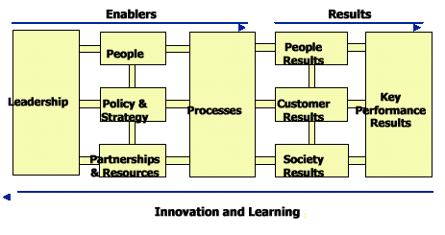

Regular Assessment of Quality is conducted at every stages at HSBC:
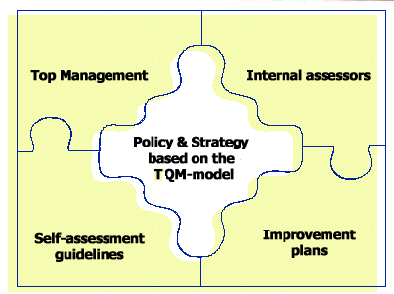
3.23.1 Instructions & Strategies For TQM:
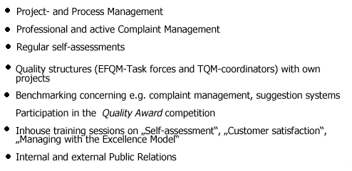
3.24 Service Marketing Strategy of HSBC Bangladesh
HSBC made its debut in Bangladesh in the year 1996. Since then it has been continuously developing itself to be the number one financial institution of Bangladesh. With its huge and enormous global image it has been able to attract a huge client base within a very short span of time. It has been continuously launching new products and services to meet customer demean head to head with its competition. To provide better quality service it opened three new branches just after two years of its entrance in Bangladesh. Another branch was added very recently to make banking convenient for people of a busy area like Dhanmondi. With world-class management styles and personnel, it has consistently attracted the banking market and as well as the banking community. A close analysis of HSBC’s marketing activities reveals that it has been following the Offensive strategies of Service Marketing. Some key aspects of this strategy are presented below:

- Reputation
- Price Premium
- High
Market Share
Sales
SERVICE
QUALITY
PROFITS

3.25 Environment & HSBC:
HSBC believes that sound business management should take account of the effects that business has on the environment, with a view to minimizing detrimental impact. The pursuit of economic growth and a healthy environment are linked; government, businesses and individuals all have a role in achieving sustainable developments.
HSBC Bangladesh has been regularly involved with various kinds of environmental activities. Some recent activities were as follows:

3.25.1 Environmental week:
To commemorate the "World Environment Day", HSBC in Bangladesh observed "HSBC Environment Week" at all its branches in Dhaka and Chittagong recently.
Sapling of different kinds of trees were distributed free to customers and staff throughout the week as part of the program, says a press release.
HSBC’s ex-manager Personal Banking, Joe Barker-Bennett said: "Environment and education are priority areas for HSBC and we believe it is important to help play our part in protecting and improving the environment. We want to share this sense of responsibility with our staff and valued customers".
3.26 HSBC in the community:
HSBC is involved in well being of the communities where it operates through philanthropy and sponsorship. HSBC Bangladesh has regularly been attached with the educational, social and political welfare of the community and has organized various programs for the well-being of the society as a whole. Some such programs were;
3.26.1 Donation to Institution of Business Administration (IBA):
As part of its donations and community sponsorship program for 2001, The Hong Kong and Shanghai Banking Corporation Limited (HSBC) in Bangladesh presented a cheques to the Institute of Business Administration (IBA), University of Dhaka.
3.26.2 Donation for Blind Students:
HSBC in Bangladesh donated Tk 90,000 to Assistance for Blind Children (ABC) as part of its donations and community sponsorship program. The cheque was handed over to Chairman of Finance Committee of ABC, Munira Khan by HSBC's Chief Executive officer Bangladesh, David J Griffiths, at the latter's office. The sponsorship will cover educational costs of all students of ABC for one year.
3.26.3 Blood Donation Program:
HSBC Bangladesh recently organized a blood donation program for the victims in the terror attack of USA. This program was organized at HSBC, Dhaka office.
3.27 INDUSTRY ANALYSIS

Industry analysis builds on customer & competitor analyses to make more strategic judgment about a market & its dynamics. One primary objective of industry analysis is to determine the attractiveness of a market to current & potential participants. A second objective of a market analysis is to understand the dynamics of the market.

The need is to identify the key emerging factors, trends & threats, opportunities & strategic uncertainties that can guide information gathering & analysis.
Porter’s approach can be applied to an industry, but it can also be applied to a market or sub-market within the industry. The basic idea is that the attractiveness of an industry or market as measured by the long-term return investment of the average firm depends largely on five factors.

A complete understanding of the competitive area helps to guide strategy design & implementation.
Micro Environment of HSBC

Driving Forces from the
External Environment
HSBcC

Industry
Attractivenessess
ess

HSBC’s
Competitors’ Moves
Anticipated
Moves from
Key Competitors

3.28 Porter’s Five Forces at HSBC

3.28.1 Rivalry among existing competitors

The rivalry among the competitors and the growth in the industry depends upon the intensity of competition. A high amount of competition is observed in the banking sector of Bangladesh. There are more than 50 commercial banks in Bangladesh that fight for there own share of the market. The national banks have the highest banking network in Bangladesh. They compete against the banks with their low cost of operation and government support. Again, Standard Chartered bank is the largest multinational banking network in Bangladesh that has its network in many metropolitans of Bangladesh. There are other international banks who also take part in the competition and are aggressive in nature. This high intensity of competition makes companies difficult to sustain in the long run.

3.28.2 Threat of new entrants
The next force highlights the possibility of new competitors entering the market. Existing firms may try to discourage new competition by aggressive expansion & other types of entry barriers. The banking sector of Bangladesh seriously faces the threat of new entrants. However the threat comes from two direction. The first threat comes with the arrival of the multinational banks and her branch expansion particularly due to the booming energy sector. Secondly, the continuous entry of local banks with lower cost structure also pose a severe threat to this industry.

In the context of HSBC the various new & upcoming Banks pose a significant threat, being new entrants in the banking sector of Bangladesh. But HSBC is aware of these potential competitors and is trying to expand countrywide to make the sector unattractive & to create entry barrier.

3.28.3 Threat of substitute products:
This force considers the potential impact of substitutes. New products that satisfy the same customer needs are important sources of competition including alternative products in the definition of product market structure identifies substitute forms of competition.

HSBC continuously faces the threat of various substitute products launched by its strong competitors in the market place. For example, the launch of premiere banking by SCB poses a strong threat on HSBC’s premium customer group and HSBC is at a condition where it should launch an even better product. More over the various consumer credit schemes offered by various local banks with lower interest rates and cost also pose a strong threat on the HSBC personal banking products. Again the lower service charges at national banks also discourages a wide group of customers to hold account in HSBC. These are some of the threats posed by substitute products in the market place.

3.28.4 Bargaining power of suppliers

The fourth force is the power of suppliers that may have impact on the producers in an industry. Companies may pursue vertical integration strategies to reduce the bargaining power of suppliers.

In the context of HSBC, suppliers are those customers and organizations that provide financing to the firm via depository schemes. If the cost of financing rises, then HSBC will have to increase the interest rate that it charges to its customer in order to remain in the business. This may result in severe customer dissatisfaction & as a result poor profitability. HSBC is aware of this devastating situation.

3.28.5 Bargaining power of buyers
Finally, buyers may use their purchasing power to influence the producers or service providers. Understanding which organizations have power & influence in the distribution channel provides important insight into the structure of competition.

In the banking sector of Bangladesh, customers have a strong bargaining power since there a large number of commercial banks providing similar services. Customers have a wide range of options in deciding where to bank. They can either go for the Multinationals or turn to new local banks for getting quality service. Others may also consider the national banks for large credit facilities. Therefore banks have to pursue the customers with attractive interest rates and provide them with tailor made customized services in order to attract the customer or hunt depositors.

In the context of HSBC, the firm is more or less free from the cope of the bargaining power of the buyers. HSBC has its own policies to carry out its operations & employees follow those rules to deal with the customers. But too much rigidity of the prevailing policies when to deal with the clients may under cut its client base as well as profitability. To overcome this worst scenario – a positive & personalized approach to the needs of customer - has become HSBC’S motto.

3.29 SWOT ANALYSIS:

STRENGHTS
Strong corporate Identity | HSBC is the leading provider of financial services worldwide. With its strong corporate image and identity it can better position in the minds of customers. This image has helped HSBC grab the personal banking sector of Bangladesh very rapidly.
Distinct operating  procedures | HSBC in known worldwide for its distinct operating procedure. The company’s Managing for Value strategy better satisfy customers needs and also keeps the firm profitable.
Distinct schedule | Everyone in HSBC from the appraiser to the top management has to work to the same schedule toward a different aspect of the same goal, interfacing simultaneously at all level over quite a long period of time.
Strong employee bonding and belongingness | HSBC employees are one of the major assets of the company. The employees of HSBC have a strong sense of commitment towards organization and also feel proud and a sense of belonging towards HSBC. the strong culture of HSBC is the main reason behind this strength.
Efficient Performance | HSBC provides hassle free customer service to its client base comparing to the other financial institutions of Bangladesh. Personalized approach to the needs of customers is its motto.
Young Enthusiastic workforce | The selection & recruitment of HSBC emphasizes on having the skilled graduates & postgraduates who have little or no previous work experience. The logic behind is that HSBC wants to avoid the problem of ‘garbage in & garbage out’. & This type young & fresh workforce stimulates the whole working environment of HSBC.
Empowered Work force | The human resource of HSBC is extremely well thought & perfectly managed. As from the very first, the top management believed in empowered employees, where they refused to put their finger in every part of the pie. This empowered environment makes HSBC a better place for the employees. The employees are not suffocated with authority but are able to grow as the organization matures.
Companionable Environment | All office walls in HSBC are only shoulder high partitions & there is no executive dining room. Any of the executives is likely to plop down at a table in its cafeteria & join in a lunch chat with whoever is there. One of the employees has said, “Its exciting to know you may see & talk to the top management at any time. You feel a part of things”.
No communication barriers | DBD has tried hard to avoid communication barriers & structural bureaucracies. The little existence of authoritative barriers among the different level of management stimulates a feeling of importance as their work get priority over the position.
Equalization | At HSBC workshops are conducted periodically. On the workshops, all people participate as equals, with new members free to openly challenge top managers.
Free exchange of communication | At HSBC the main objective is to setting up workshops are to remove authority from an artificial spot at the top, & place it where the most knowledgeable people are, the people closest to the operations. The free exchange of ideas is reinforced by a policy of “constructive confrontation”. Each employee is expected to challenge ideas openly & aggressively, but never attack an individual’s motives for presenting an idea.
MBO | HSBC also has Management by Objectives (MBO) everywhere. Each person has multiple objectives. All the employees must have to get the approval of their bosses on what they are going to do. Later they review as how well they have performed their job with their management as well as the peer group.
“One-to-one” meeting | The MBO makes the review a communication device among various groups. The key to the system is a “one-to-one” meeting between a supervisor & a subordinate. In the meeting, the problems in dealing with customers are put forward first & every one dug it to solve them.
Modern Equipment & technology | HSBC owns the best banking and information technology equipments in Bangladesh. It ultra modern banking systems starting from terminal pc’s to HUB’s are based on the international HSBC group standards and are the latest. The Hexagon product is one of the best examples in this context.
Visually Appealing Facilities | HSBC has some of the best visually appealing branches and office premises in Dhaka & Chittagong that highly attracts customers attentions and customers also feel the international environment while banking with HSBC.

WEAKNESSES
Narrow operating span | HSBC has a very narrow operating span in Bangladesh. It has only 2 full service branches in Bangladesh situated only at Dhaka and Chittagong. Various geographic segments are currently not availing the services of HSBC due to inconvenient branch location or absence of neighborhood branches.
Absence of strong Marketing Activities | HSBC currently don’t have any strong marketing activities through mass media e.g. Television. TV ads play a vital role in awareness building. HSBC has no such TV ad campaign.
No investment products | Currently the personal banking divisions of HSBC do not have investment products for its customers. The banning of investment loan by central bank posses a strong pressure to design new products.
Lack of customer confidence | AS HSBC is fairly new to the banking industry of Bangladesh average customers lack the confidence in HSBC and judge the bank as an average new bank.
Too many contract workers | HSBC has contract workers who lack the commitment with superior quality service and also are pretty dissatisfied as being a contract worker. This hampers the bank’s service quality as a whole.

Low remuneration Package | The remuneration package for the entry level officers are considerable low. Since other foreign and local banks offer a more lucrative salary package, it will be difficult for HSBC to attract MBA’s in future with its current salary package.
Diversification | HSBC can peruse a diversification strategy in expanding its current line of business. The management can consider options of starting merchant banking or diversify in to leasing and insurance. As HSBC is one of the leading provider of all financial services, in Bangladesh it can also offer these services.
Credit Cards | This is one of the most popular and emerging product in Bangladesh which offers customers total financial mobility. Various other banks and institutions are currently offering this product. HSBC can also take advantage of this product and grab the market share.
Acquisition | HSBC is one of the experts in acquiring various firms and organizations. In Bangladesh it can also diversify quickly by acquiring various local established banks and increase it’s total operation within Bangladesh rapidly.

OPPORTUNITIES
High demand of Housing loans | Since housing is one of the basic needs of people, there is a high demand of housing loans. HSBC personal banking division can focus on this category of products and grab this segments of customers.
Distinct operating procedures | HSBC is noted for its distinct operating procedures. Repayment capacity as assessed by HSBC of individual client helps to decide how much one can borrow. As the whole lending process is based on a client’s repayment capacity, the recovery rate of HSBC is close to 100%. This provides HSBC financial stability & gears up HSBC to be remain in the business for the long run.
Countrywide network | The ultimate goal of HSBC is to expand its operations to whole Bangladesh. Nurturing this type of vision & mission & to act as required, will not only increase HSBC’s profitability but also will secure its existence in the log run.
More experienced & managerial know-how | The top management team of HSBC is expert in banking activities. The operating policies established by them are unique & unified. All the members of the team carry out their management roles exhaustively. They equally contributed to HSBC’s superior leadership, by carrying out their unique roles. They worked well together, respecting each other’s abilities, & arguing openly & without any rancor when they disagree.

ThreatS
Upcoming Banks | The upcoming private local & multinational banks posses a serious threat to the existing banking network of HSBC. it is expected that in the next few years more commercial banks will emerge. If that happens the intensity of competition will rise further and banks will have to develop strategies to compete against and win the battle of banks.
Lose of Customers | Absence of various products such as credit card, housing loans are causing various customers to detract from HSBC. This is a serious threat for HSBC Bangladesh.
Moderate levels of Customer Satisfaction | HSBC should continuously improve its customer service strategies and the overall service quality needs to win the customer satisfaction undoubtedly.
Default Culture | This a major problem in Bangladesh. As HSBC is a very new organizations the problem of non-performing loans or default loans is very minimum or insignificant. However, as the bank becomes older this problem will arise enormously and the bank may find itself in a more threatening environment. Thus HSBC has to remain vigilant about this problem so that proactive strategies are taken to minimize this problem.

4.Work Experience at HSBC
Headquartered in London, HSBC is considered as one of the largest banking and financial services organization in the world. In Bangladesh it has made its place as the fastest growing bank. Being able to work in this world renowned organization I find myself lucky. I got the opportunity to work in one of the most vital department of HSBC- The Customer Service Department (CSD).

I was offered an internship for three months time in the customer service department and when my internship tenure was about to finish, I was offered an extension for another three months and am still working on the extension period. I am thoroughly enjoying the work at the customer service department. The work experience has given me a good idea of the overall banking system of Bangladesh and has taught me the professionalism at work place.
5. THE PROJECT

5.1 Introduction

Banking is one the most competitive industries of Bangladesh that has seen a huge amount of growth during the last decade. A large number of new banks have made their places in the industry and yet there are more to register in the list. In such a highly competitive service industry, the importance of customer satisfaction cannot be de-emphasized. Improved customer satisfaction and loyalty gives a firm better base than its rivals and allows it flourish in the industry.

This project deals with the service quality and customer satisfaction of HSBC Bangladesh. A survey was conducted on the customers of HSBC, Dhaka. The objective was to assess the level of importance the customers of HSBC put across various service level attributes and also to determine how well HSBC was satisfying the customers on those service grounds. The results of this survey are then analyzed to determine the most important aspects of the service and discover various drivers of overall satisfaction. Various important issues of customer satisfaction are also presented in light of the findings of the survey. Lastly, the findings are examined to prescribe a set of specific recommendations to improve the overall service quality according to customers expectations and also to solve the existing problems in the whole organizational level.

5.2 Objective of the project
General Objective
General objective is to assess the level of importance the customers of HSBC put across various service level attributes and also to determine how well HSBC was satisfying the customers on those service grounds.

Specific Objectives:
- Presentation of an introduction to the HSBC Group
- Provide information on HSBC Bangladesh
- To determine various attributes of service quality in Commercial banks.
- To assess the expectation & satisfaction levels of HSBC customers
- To determine the most important attributes of service quality
- To determine the most satisfied and dissatisfied aspects of the bank
- To identify the most satisfied demographic segments.
- To determine the relation between satisfaction & recommendation of the bank.
- To determine the relation between complaint resolution & satisfaction.
- To identify the major competitors of the bank in the customers minds.
To recommend strategies to improve the overall service quality and customer satisfaction of HSBC Bangladesh.

5.3 Significance Of The Study

Customer satisfaction related to expectation fulfillment is an extremely important and critical issue facing organizations in the complex business environment of today. The banking industry is certainly not an exception to this premise. In fact, it has been widely held in financial institutions that customer satisfaction may be the most influential factor in the selection of a banking institution. Likewise, with all of the changes taking place in the financial marketplace and the increase in competition, it becomes apparent that more attention must be given to customer service and satisfaction. Based on what customers have indicated in various banking situations, personalized and quality customer service will provide banks with the ability to be more competitive than their counterparts. Therefore, it is important to obtain customer input as to the services and products they desire to avoid situations where the institution fails to live up to customer expectations due to failed communications.
This report explored the importance customer place on various aspects of the service provided by HSBC and at the same time assessed the current satisfaction levels of the customers. Such finding will be beneficial for the management in attempting to improve the overall service quality and also to promote the company’s services to customers. Finally, the current level of satisfaction will give an indication about the overall quality of the service provided currently from customers’ point of view and thus giving an opportunity to build on strengths and correcting weaknesses and dark sides of the service. So the study will be very useful for the top management in improving the overall service quality and customer satisfaction.
5.4 Hypothesis:
The service that customers place most importance in are well satisfied by HSBC, Bangladesh.

5.5 METHODOLOGY
5.5.1 Type of research:
In this study, exploratory research was undertaken to gain insights and understanding of the overall banking industry and also to determine some of the attributes of service quality in Banks. After, that a more comprehensive conclusive research was undertaken to fulfill the main purpose of the study.

5.6 Survey Findings:

5.6.1 Exploratory Research
An exploratory research was conducted to explore through the various aspects of customer satisfaction and to provide insights and understandings of the overall service environment of banking. In this phase of research, managers and customers were interviewed to determine the service attributes that were most important in the selection of banks and also were responsible for the overall customer satisfaction.

The interviewees pointed out various important attributes that they thought were important to customers in assessing service quality and satisfaction. In this part of the project, my organization supervisor Ms. Zinia Amreen helped me out the most. The most common and relevant responses were then selected from the pool of attributes and were categorized according to five dimensions of service quality. Some such attributes are presented below along with the associated service quality dimension:

Reliability:
Attributes such as keeping service promises, giving appropriate solution, error resolution were categorized in this dimension of service quality. This dimension was the most uniform among the respondents.

Responsiveness:
Speed of service, willingness to help, willingness to search for solutions, etc. were the attributes that related to the responsiveness dimension of service quality.

Assurance:
The respondents also mentioned friendliness & professionalism of the employees and feeling of safety with them while describing the service attributes. These aspects were close to the assurance dimension and thus were categorized in this section.

Care and Empathy:
Aspects like Individual attention, understanding customers needs and interests were categorized in this section.

Tangibles:
Respondents also mentioned various attributes of services provided by banks that relate to physical evidences, facilities, technologies, neatness of the premises, etc. All these information was grouped in the tangibles dimension of service quality.

Apart from these general attributes discussed above, respondents also mentioned the vital role of location advantages and the features of products & services in forming overall customer satisfaction. Due to such emphasis on these aspects, they were also included in the list of attributes that affected service quality.

The various product & service features that were mentioned in the discussions were fees & charges, various product schemes, rates of credit or savings schemes, etc.
These various aspects that were found in this phase of research were used to construct a complete questionnaire for use in the next phase of the survey. Each attribute were then transformed into a questionnaire to find out the importance placed by customers and satisfaction towards that specific questionnaire. The questionnaire was divided into various parts that included the service dimension and other important aspect of the service.

Thus the exploratory research discovered ideas, provided insights to the main survey and the findings in this phase formed the basis of the questionnaire used in next main survey.

5.6.2 Importance to Customer and Satisfaction at HSBC:
In this section the findings of the HSBC customers’ importance put to various service attributes and satisfaction at HSBC are shown briefly. The results are presented according to the various service quality dimensions. Each dimension consists of its own specific questions. The results of the survey are presented according to these questions that were asked to the respondents with the help of a structured questionnaire. The results of this study are as follows:

Reliability:
Aspects relating to reliability dimension of service quality were asked in 3 different questions. The results are as follows:

Q1: Provides services within the time promised.
The respondents placed a high importance in this characteristic of the service. The mean importance score was 4.40 (0n a 5 point scale - where 5 is the highest score). Again, 46% respondents score 5, which depicted that customer’s expectations were high in this characteristic. The mean satisfaction score in this attribute was 3.56, which is not very satisfactory. Only 6% respondents were highly satisfied (scored 5) with this aspect and 52% were somewhat satisfied (scored 4). The results are presented below:
Q1
Importance Score | Percentage (%) | Satisfaction Score | Percentage (%) | Cumulative %
5 | 46 | 5 | 6 | 6
4 | 48 | 4 | 52 | 58
3 | 6 | 3 | 34 | 92
2 |  | 2 | 8 | 100
1 |  | 1

Q2: Employees give appropriate solution to problems.
The mean importance score for this attribute was 4.00, which makes this attribute important. Moreover, around 78% of the respondents scored 4 or above. The average satisfaction score was 3.34. Results show that only 36% respondents were satisfied in this attribute and most of the others were on the neutral side.
Q2
Importance Score | Percentage (%) | Satisfaction Score | Percentage (%) | Cumulative %
5 | 24 | 5 | 4 | 4
4 | 54 | 4 | 32 | 36
3 | 20 | 3 | 58 | 94
2 | 2 | 2 | 6 | 100
1 |  | 1

Q3: Errors and mistakes corrected promptly:
This attribute was found to be the most important attribute within reliability dimension having a mean importance score of 4.44. All the respondents placed an importance score of 4 or above with 44% respondents scoring 5. Consequently, most of the customers were also satisfied with this attribute and the mean satisfaction score was 3.90 where 70% of the respondents placed a satisfaction score of 4 or above.

Q3
Importance Score | Percentage (%) | Satisfaction Score | Percentage (%) | Cumulative %
5 | 56 | 5 | 22 | 22
4 | 44 | 4 | 48 | 70
3 |  | 3 | 28 | 98
2 |  | 2 | 2 | 100
1 |  | 1

Summary Statistics: Reliability
Summary of all the reliability attributes reveals that customers placed a mean importance score of 4.28 and mean satisfaction score of 3.60 on the reliability dimension of the service quality. The results are shown below:
Reliability Dimension
 | Mean Score
 | Importance | Satisfaction
Q1 | 4.40 | 3.56
Q2 | 4.0 | 3.34
Q3 | 4.44 | 3.9
Mean | 4.28 | 3.60

Responsiveness:
3 attributes were grouped in this dimension and the respondents were asked to express their opinions. Results of the various aspects are shown below:

Q4: Employees give you prompt service
An extremely high importance was given in this attribute of service where the mean importance score was 4.58. 94% of the respondents placed an importance score of 4 or above. The average satisfaction score of this attribute was 3.60. Only 8% of all respondents were highly satisfied with the service where 48% were somewhat satisfied. The rest of the respondents were indifferent in their responses. The results are as follows:

Q4
Importance Score | Percentage (%) | Satisfaction Score | Percentage (%) | Cumulative %
5 | 64 | 5 | 8 | 8
4 | 30 | 4 | 48 | 56
3 | 6 | 3 | 40 | 96
2 |  | 2 | 4 | 100
1 |  | 1

Q5 - Employees are always willing to help:
A moderate importance was placed on this attribute of responsiveness dimension where the mean importance score was 3.86. 84% of the respondents scored 4 or above in their importance opinions. The average satisfaction score across this attribute was significantly low and was 2.90 only. Respondents showed severe dissatisfaction with this attribute. Only 14% respondents scored 4 or above in their satisfaction ratings. The results are as follows:

Q5
Importance Score | Percentage (%) | Satisfaction Score | Percentage (%) | Cumulative %
5 | 12 | 5 | 6 | 6
4 | 62 | 4 | 8 | 14
3 | 26 | 3 | 64 | 78
2 |  | 2 | 14 | 92
1 |  | 1 | 8 | 100

Q6 – Employees always search for solutions:
Moderate importance was observed across this attribute where the mean importance score was 3.46. Most of the respondents were indifferent while expressing their importance towards this aspect. But the satisfaction scores of this attribute were dissatisfactory and the mean was 2.78. 30% respondents scored 2 or less than 2 and only 16% respondents scored 4 or above. The results are as follows:

Q6
Importance Score | Percentage (%) | Satisfaction Score | Percentage (%) | Cumulative %
5 | 6 | 5 | 4 | 4
4 | 34 | 4 | 8 | 12
3 | 60 | 3 | 58 | 70
2 |  | 2 | 22 | 92
1 |  | 1 | 8 | 100

Summary Statistics: Responsiveness
The responsiveness attributes reveal that customers placed a mean importance score of 3.97, which was slightly lower than the reliability dimension. The mean satisfaction score was 3.09 on the responsiveness dimension, which is significantly lower than reliability scores. The results are shown below:

Responsiveness
 | Mean
 | Importance | Satisfaction
Q4 | 4.58 | 3.6
Q5 | 3.86 | 2.9
Q6 | 3.46 | 2.78
Mean | 3.97 | 3.09

Assurance:
Aspects relating to assurance dimension of service quality were asked in 3 different questions. The results are as follows:

Q7- Friendliness & Courtesy of the Employees:
This attribute was also found to be another of the most important ones having a mean importance score of 4.52. All the respondents placed an importance score of 4 or above with 52% respondents scoring 5. Consequently, the customers were also highly satisfied with this attribute and the mean satisfaction score was 4.48 where all the respondents placed a satisfaction score of 4 or above.

Q7
Importance Score | Percentage (%) | Satisfaction Score | Percentage (%) | Cumulative %
5 | 52 | 5 | 48 | 48
4 | 48 | 4 | 52 | 100
3 |  | 3 |  | 100
2 |  | 2 |  | 100
1 |  | 1 |  | 100

Q8 – Professionalism of the Employees:
Mean importance score of this attribute was 3.96 where 76% respondents scored 4 or above. The mean satisfaction score for this attribute was 2.96 and were somewhat dissatisfactory. 80% of the respondents scored 3 or less than that. The results are as follows:

Q8
Importance Score | Percentage (%) | Satisfaction Score | Percentage (%) | Cumulative %
5 | 20 | 5
4 | 56 | 4 | 20 | 20
3 | 24 | 3 | 60 | 80
2 |  | 2 | 16 | 96
1 |  | 1 | 4 | 100

Q9- You feel safe in your transactions with HSBC:
This attribute was found to be important and the mean importance score was 4.04. 70% respondents scored 4 or above in the importance ratings. The respondents also gave high satisfaction scores with mean of 4.42. 50% of the respondents were highly satisfied with this aspect of assurance. The results are shown below:

Q9
Importance Score | Percentage (%) | Satisfaction Score | Percentage (%) | Cumulative %
5 | 34 | 5 | 50 | 50
4 | 36 | 4 | 42 | 92
3 | 30 | 3 | 8 | 100
2 |  | 2 |  | 100
1 |  | 1 |  | 100

Summary Statistics: Assurance
Summary of all the assurance attributes reveals that customers placed a mean importance score of 4.17 and mean satisfaction score of 3.95 on the assurance dimension of the service quality. The results are shown below:
Assurance
 | Mean
 | Importance | Satisfaction
Q7 | 4.52 | 4.48
Q8 | 3.96 | 2.96
Q9 | 4.04 | 4.42
Mean | 4.17 | 3.95

Care & Empathy:
3 attributes were grouped in this dimension and the respondents were asked to express their opinions. Results of the various aspects are shown below:

Q10 – HSBC gives you individual attention
Mean importance score of this attribute was 4.08 where 80% respondents scored 4 or above. The mean satisfaction score for this attribute was 3.32 and where respondents were moderately satisfied. 58% of the respondents scored 3 or less than that. The results are as follows:

Q10
Importance Score | Percentage (%) | Satisfaction Score | Percentage (%) | Cumulative %
5 | 28 | 5 | 12 | 12
4 | 52 | 4 | 30 | 42
3 | 20 | 3 | 42 | 84
2 |  | 2 | 10 | 94
1 |  | 1 | 6 | 100

Q11 – Employees of HSBC understands your specific needs:
High importance was placed on this attribute of care & empathy dimension where the mean importance score was 4.28. 90% of the respondents scored 4 or above in their importance opinions. The average satisfaction score across this attribute was significantly low and was 2.90 only. Respondents showed severe dissatisfaction with this attribute. Only 14% respondents scored 4 in their satisfaction ratings. The results are as follows:
Q11
Importance Score | Percentage (%) | Satisfaction Score | Percentage (%) | Cumulative %
5 | 38 | 5 | 0 | 0
4 | 52 | 4 | 14 | 14
3 | 10 | 3 | 64 | 78
2 |  | 2 | 20 | 98
Q12 - HSBC has your best interest at Hearts:
Moderate importance was given to this aspect and the mean importance score was 3.62. But the mean satisfaction were for this attribute was the lowest of all the attributes and was 2.84. 88% respondents scored 3 or less than that and only 12% respondents scored 4 on this aspect of care and empathy.

Q12
Importance Score | Percentage (%) | Satisfaction Score | Percentage (%) | Cumulative %
5 | 12 | 5 | 0 | 0
4 | 40 | 4 | 12 | 12
3 | 46 | 3 | 64 | 76
2 | 2 | 2 | 20 | 96
1 |  | 1 | 4 | 100

Summary Statistics: Care & Empathy
The statistics revealed that customers placed a mean importance score of 3.99 on the care and empathy dimension. The mean satisfaction score was 3.02 on this dimension, which is significantly lower than the other dimensions. The results are shown below:

Care & Empathy
 | Mean
 | Importance | Satisfaction
Q10 | 4.08 | 3.32
Q11 | 4.28 | 2.9
Q12 | 3.62 | 2.84
Mean | 3.99 | 3.02

Tangibles:
6 questions relating to the tangible dimension were asked to the respondents. These questions covered various tangible aspects of the services provided by HSBC. The results are shown below:
Q13: HSBC has visually appealing facilities
Moderate importance was given to this attribute and the mean value was 3.50. Respondents very satisfied with this aspect and the mean satisfaction score was 4.34 where 98% respondents were found to satisfied. The results are as follows:
Q13
Importance Score | Percentage (%) | Satisfaction Score | Percentage (%) | Cumulative %
5 | 16 | 5 | 36 | 36
4 | 26 | 4 | 62 | 98
3 | 50 | 3 | 2 | 100
2 | 8 | 2 |  | 100
1 |  | 1 |  | 100

Q14 – HSBC employees appear neat:
The mean importance score of this attribute was 3.48. The mean satisfaction score was 4.56 where all the respondents were found to be satisfied and score 4 or above. The results are as follows:
Q14
Importance Score | Percentage (%) | Satisfaction Score | Percentage (%) | Cumulative %
5 | 12 | 5 | 56 | 56
4 | 42 | 4 | 44 | 100
3 | 28 | 3 |  | 100
2 | 18 | 2 |  | 100
1 |  | 1 |  | 100

Q15 – HSBC has convenient hours of operation:
Moderate importance and satisfaction was observed in this aspect where the mean importance and satisfaction scores were 3.62 & 3.40 respectively.
Q15
Importance Score | Percentage (%) | Satisfaction Score | Percentage (%) | Cumulative %
5 | 14 | 5 | 4 | 4
4 | 34 | 4 | 36 | 40
3 | 52 | 3 | 56 | 96
2 |  | 2 | 4 | 100
1 |  | 1 |  | 100
Q16 – Statements are easily understood:
A high importance was given on this attribute where the mean score was 4.02. But the respondents was found to extremely dissatisfied with this attribute and the mean was 2.56 where 96% respondents scored 3 or less than that.
Q16
Importance Score | Percentage (%) | Satisfaction Score | Percentage (%) | Cumulative %
5 | 26 | 5 | 0 | 0
4 | 50 | 4 | 4 | 4
3 | 24 | 3 | 50 | 54
2 |  | 2 | 44 | 98
1 |  | 1 | 2 | 100

Q17 – Statements are reliable and accurate:
A mean importance score of 4.04 depicted that respondents placed high importance to this attribute. The respondents were also very satisfied with this aspect and mean satisfaction was 4.28 where 94% respondents scored 4 or higher. The results are as follows:

Q17
Importance Score | Percentage (%) | Satisfaction Score | Percentage (%) | Cumulative %
5 | 24 | 5 | 34 | 34
4 | 56 | 4 | 60 | 94
3 | 20 | 3 | 6 | 100
2 |  | 2 |  | 100
1 |  | 1 |  | 100

Q18 – HSBC has modern equipments and technologies that better satisfy your needs:
Respondents were indifferent while expressing the importance of this attribute and the mean was 3.40. But the satisfaction scores across this attribute were highest with a mean of 4.50 where all the respondents scored 4 or higher.

Q18
Importance Score | Percentage (%) | Satisfaction Score | Percentage (%) | Cumulative %
5 | 8 | 5 | 50 | 50
4 | 34 | 4 | 50 | 100
3 | 48 | 3 |  | 100
2 | 10 | 2 |  | 100
1 | 0 | 1 |  | 100

Summary Statistics: Tangibles
The moderate importance was given to this dimension of service quality. The mean importance score across this dimension was 3.68. This dimension was found to be the most satisfied one with mean score of 3.94
Tangibles
 | Mean
 | Importance | Satisfaction
Q13 | 3.5 | 4.34
Q14 | 3.48 | 4.56
Q15 | 3.62 | 3.4
Q16 | 4.02 | 2.56
Q17 | 4.04 | 4.28
Q18 | 3.40 | 4.50
Mean | 3.68 | 3.94

In addition to these five dimensions of service quality, two additional dimensions were also considered and analyzed in the survey. These were ‘Locations’ and ‘Products & services’. Survey results across these dimensions are also presented to provide a better picture of the services.

Locations:
4 questions were asked in this category and the results are presented below:
Q19 – Branch locations are convenient:
High importance were given to this attribute with a mean score of 4.54. But the satisfaction scores were very low with a mean of 2.76 where 34% respondents were dissatisfied with the locations.
Q19
Importance Score | Percentage (%) | Satisfaction Score | Percentage (%) | Cumulative %
5 | 56 | 5 | 2 | 2
4 | 42 | 4 | 12 | 14
3 | 2 | 3 | 52 | 66
2 |  | 2 | 28 | 94
1 |  | 1 | 6 | 100

Q20 – ATM locations are convenient
A high importance was also given to this attribute and the mean was 4.54. Again the respondents were moderately satisfied with the location of ATM’s and the mean score was 3.56 with 58% respondents being satisfied with the locations.
Q20
Importance Score | Percentage (%) | Satisfaction Score | Percentage (%) | Cumulative %
5 | 54 | 5 | 4 | 4
4 | 46 | 4 | 50 | 54
3 |  | 3 | 44 | 98
2 |  | 2 | 2 | 100
1 |  | 1 |  | 100
Q21 – Premises are neat and clean
Moderate importance was given to this attribute with a mean of 3.68. The respondents were highly satisfied among this attribute and the mean satisfaction score was 4.38 with 98% respondents scoring 4 or above.
Q21
Importance Score | Percentage (%) | Satisfaction Score | Percentage (%) | Cumulative %
5 | 16 | 5 | 40 | 40
4 | 44 | 4 | 58 | 98
3 | 32 | 3 | 2 | 100
2 | 8 | 2 |  | 100
Q22 – Parking spaces are sufficient:
Average importance was observed in this attribute with a mean score of 3.60. Again the respondents were also highly satisfied with this attribute scoring a mean of 4.20 where 86% respondents were satisfied with the facilities.
Q22
Importance Score | Percentage (%) | Satisfaction Score | Percentage (%) | Cumulative %
5 | 22 | 5 | 34 | 34
4 | 30 | 4 | 52 | 86
3 | 34 | 3 | 14 | 100
2 | 14 | 2 |  | 100

Summary Statistics: Locations
The results indicated a high importance towards this dimension and the mean score was 4.09. While on the other hand, the mean satisfaction score across this dimension was found to be 3.73. The results are presented below:

Locations
 | Mean
 | Importance | Satisfaction
Q19 | 4.54 | 2.76
Q20 | 4.54 | 3.56
Q21 | 3.68 | 4.38
Q22 | 3.6 | 4.2
Mean | 4.09 | 3.73

Products & Services:
In this category various other attributes of HSBC products & services were considered and the customer expectations and satisfaction towards these attributes were judged. 8 different aspects were analyzed and the results are shown below:

Q23 – Fees and Service charges:
Customer expectation towards this attribute was very high and mean score was 4.20. On the other hand, satisfaction scores on this aspect was also very high and the mean was 4.24 where 82% respondents were satisfied with this aspect.
Q23
Importance Score | Percentage (%) | Satisfaction Score | Percentage (%) | Cumulative %
5 | 44 | 5 | 42 | 42
4 | 34 | 4 | 40 | 82
3 | 20 | 3 | 18 | 100
2 | 2 | 2 |  | 84
1 |  | 1 |  | 84

Q24 – Savings or Deposit services:
Mean importance of this aspect was 4.32 and mean satisfaction scores were 4.16. This entails that this category resembled high importance and high satisfaction of the respondents.
Q24
Importance Score | Percentage (%) | Satisfaction Score | Percentage (%) | Cumulative %
5 | 36 | 5 | 30 | 30
4 | 60 | 4 | 56 | 86
3 | 6 | 3 | 14 | 100
2 |  | 2 |  | 100

Q25 – Investment services:
Average importance was given to this attribute and the mean was 3.43. Satisfaction in this category was poor and the mean value was 2.38 where 60% respondents were dissatisfied with the investment services of the bank.
Q25
Importance Score | Percentage (%) | Satisfaction Score | Percentage (%) | Cumulative %
5 | 10 | 5 | 2 | 2
4 | 40 | 4 | 2 | 4
3 | 36 | 3 | 32 | 36
2 | 10 | 2 | 60 | 96
1 | 4 | 1 | 4 | 100
Q26 – Loan or credit services:
High importance was given to this attribute and the mean was 4.06. Moderate satisfaction scores were obtained with a mean of 3.88 where 74% customers placed a value of 4 or higher.
Q26
Importance | Percentage | Satisfaction | Percentage | Cumulative
5 | 52 | 5 | 24 | 24
4 | 28 | 4 | 50 | 74
3 | 18 | 3 | 20 | 94
2 | 2 | 2 | 2 | 96
1 |  | 1 | 4 | 100

Q27 – Cash & remittance services:
A mean importance of 3.94 was observed in this aspect of products and services. The satisfaction scores of this category was satisfactory with a mean of 4.22 where 82% customer were satisfied with the cash and remittance services.

Q27
Importance Score | Percentage (%) | Satisfaction Score | Percentage (%) | Cumulative %
5 | 20 | 5 | 44 | 44
4 | 54 | 4 | 38 | 82
3 | 26 | 3 | 14 | 96
2 |  | 2 | 4 | 100
1 |  | 1 |  | 100

Q28 – Telephone banking services:
Respondents were somewhat indifferent in expressing their importance towards this aspect and a mean of 3.44 was found. On the other hand, customer were highly pleased with this service of HSBC and the mean satisfaction score was 4.46 where 96% customers were satisfied with this service.
Q28
Importance Score | Percentage (%) | Satisfaction Score | Percentage (%) | Cumulative %
5 | 12 | 5 | 50 | 50
4 | 32 | 4 | 46 | 96
3 | 44 | 3 | 4 | 100
2 | 12 | 2 |  | 100

Q29 – Rates on Loans:
High importance was placed on this feature and the mean score was 4.34. But average satisfaction scores were found on this category with a mean of 3.14. Only 2% customers were satisfied with the rates of loans whereas 60% were

indifferent. The results are shown below:
Q29
Importance Score | Percentage (%) | Satisfaction Score | Percentage (%) | Cumulative %
5 | 36 | 5 | 2 | 2
4 | 62 | 4 | 26 | 28
3 | 2 | 3 | 60 | 88
2 |  | 2 | 8 | 96
1 |  | 1 | 4 | 100
Q30 – Rates on Savings:
Moderately high importance scores were obtained in this category and the mean was 3.92. But the satisfaction scores in this category were poor and the mean was 2.40. Only 6% customers scored 4 or higher and the rest scored negatively.
Q30
Importance Score | Percentage (%) | Satisfaction Score | Percentage (%) | Cumulative %
5 | 20 | 5 |  | 0
4 | 52 | 4 | 6 | 6
3 | 28 | 3 | 38 | 44
2 |  | 2 | 46 | 90
1 |  | 1 | 10 | 100

Summary statistics: Products & services
The means importance score of this dimension was 3.95 and the mean satisfaction score was 3.14. The results are shown below.
 | Mean
 | Importance | Satisfaction
Q23 | 4.2 | 4.24
Q24 | 4.32 | 4.16
Q25 | 3.42 | 2.38
Q26 | 4.06 | 3.88
Q27 | 3.93 | 4.22
Q28 | 3.44 | 4.46
Q29 | 4.34 | 3.14
Q30 | 3.92 | 2.4
Mean | 3.95 | 3.61

5.6.2.1 GAP SCORE ANALYSIS ON THE DIMENSIONS:
Gap scores give a meaningful indication as to where customers are mostly dissatisfied. Gap scores are expressed as the difference between mean importance and satisfactions (S - I) and are most often negative numbers because customer perceptions or satisfaction of the service typically fall short of customer expectations. The result of the survey conducted on the customers of HSBC show that the only dimension where customer perception exceeded expectation is tangibles (APPENDIX), which had a positive gap score of 0.26. The dimension that had highest gap was the empathy dimension with a negative gap score of –0.97. The gap scores of assurance was –0.22, which depicted the perceptions fall slightly short of expectations. Again reliability, responsiveness were other dissatisfied dimension with negative gap scores of –0.68 & -0.87 respectively. The location and products dimensions showed slight moderate gaps and the scores were –0.37 & -0.31 respectively. The gap scores of the various dimensions are shown graphically below:
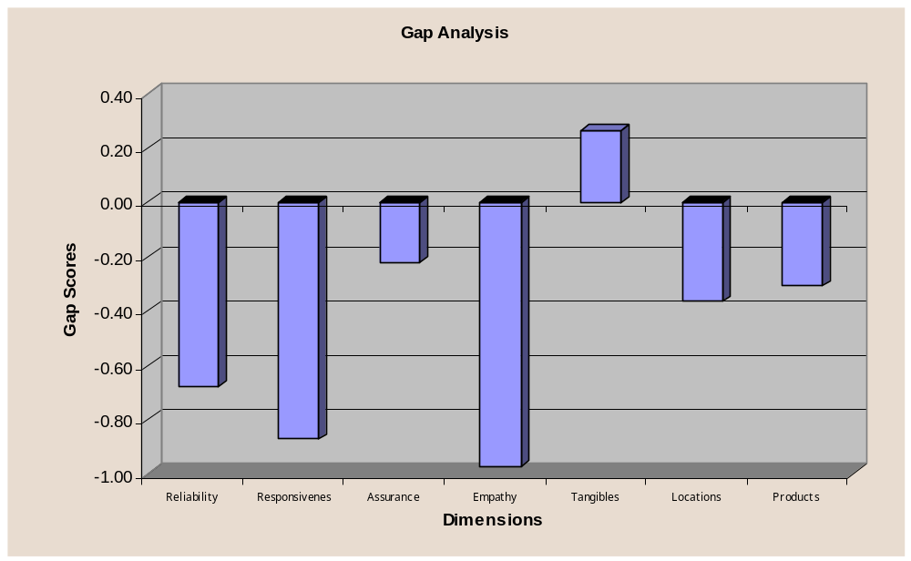
5.6.2.2 Service compared to Other banks:
The respondents were asked to rate the HSBC in comparison with the services of other banks (Q31). The results showed that only 6% of the customer thought that the services are much better compared to other banks whereas 30% of the respondents believed that the services are worse compared to competitors. The results are shown below:

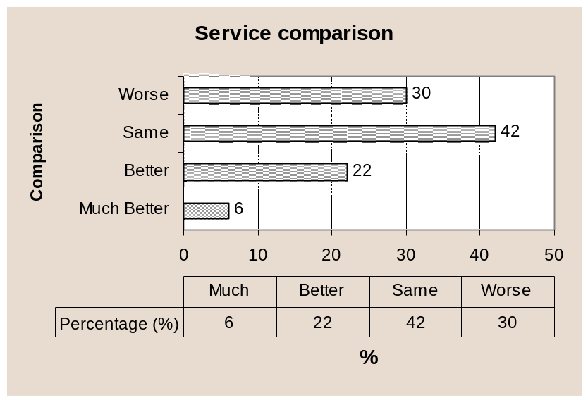

5.6.2.3 Complaint Resolution:
The respondents were asked to state that weather they had placed any complaints to HSBC during their service life cycle (Q32). Around 46% respondents stated that they had problems with HSBC and had complained where as 54% did not have problems. The next phase of this question asked the problem faced customers’ weather that complaint was resolved. In this part, 62% of the problem complainants stated that the problem was still there. The results of this survey are presented below:

Q32a | Placed Complaints |  | Q32b | Complaint Resolved
 | Frequency % |  |  | Frequency %
Yes | 46 |  | Yes | 38
No | 52 |  | No | 62

5.6.2.4 Overall Satisfaction With HSBC:
Apart from all the individual ratings of various attributes, features and aspects the respondents were asked to rate their overall satisfaction with HSBC (Q31) on a 5-point scale. The results of this question gave an idea of the overall satisfaction with HSBC. The findings were used for determining correlations with various other attributes of the services. The results of this question showed that only 8% customers were highly satisfied with the bank and score 5 on this questions. This segment represented the most loyal group of customers. On the other hand 16% of the respondents were found to be dissatisfied with the services of the bank, which is higher than the satisfied group. The findings of this questions are presented graphically below:

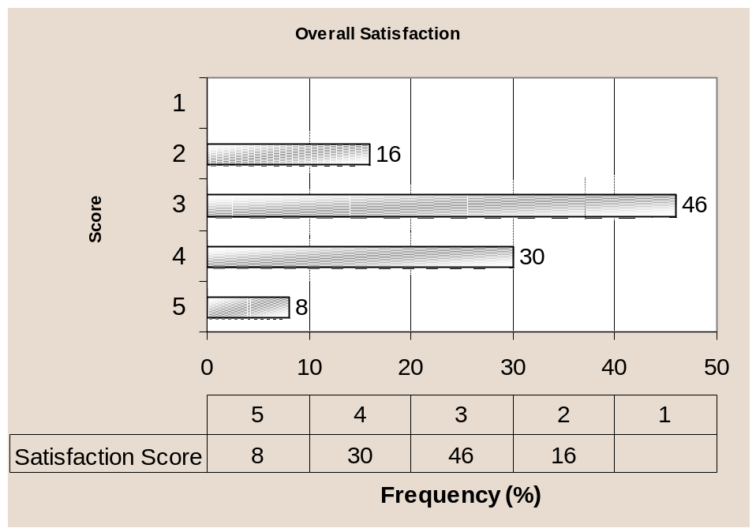

5.7 IMPLICATION OF RESULTS

5.7.1 Drivers of Satisfaction:
If banks are to improve their satisfaction and loyalty ratings and differentiate themselves from the competition, they need to understand what really drives satisfaction and loyalty. They also need to know which areas have the greatest room for improvements. There is little point in intervening resources in areas that are important but are performing well, or in areas which there is much room for improvement but they are not important in driving satisfaction and loyalty. Thus HSBC managers need to know what levers to push to increase these measures of success.

One useful tool is to search for the most important attributes which allows to analyze those areas that are important and have much room for improvements. In the following section the most important attributes will be discussed.

5.7.2 Most important attributes of the Service:
The analysis of the importance scores across various attributes of service quality dimension pointed out some attributes that were highly important to customers(APPENDIX). These attributes are listed below according to importance:
- Speed of service (Q4)
- Location of the branches (Q19)
- Location of the ATM’s (Q20)
- Friendliness & courtesy of the employees (Q7)
- Promptness of error correction (Q3)
- Keeping Promises (Q1)
- Rates on Loans (Q29)
- Savings services (Q24)
- Recognition of needs (Q11)
- Fees & service charges (Q23)

These attributes were considered as the drivers of satisfaction for the customers. Satisfaction across these attributes influenced the overall satisfaction towards the banks services. Some other attributes, which were important to customers but not considered as drivers of satisfaction are listed below:

- Individual attention (Q10)
- Loan or credit services (Q26)
- Safety of transactions with HSBC (Q9)
- Reliability and accuracy of the statements (Q17)
- Clarity of the statements (Q16)
- Problem solving interest within employees (Q2)
- Professionalism of the employees (Q8)

The rest of the attributes administered during the survey were found to moderately important or less important for the customers and were not considered by them while deciding on satisfaction scores.

5.7.3 Satisfaction towards the most important attributes:
As mentioned earlier, the major concern of managers is to find out satisfaction of the customers across the various drivers of satisfaction (APPENDIX). The results of the survey showed that customers were satisfied only across the following drivers of satisfaction:

- Friendliness & courtesy of the employees (Q7)
- Fees and service charges (Q23)
- Saving and deposit services (Q24)
- Promptness error correction (Q3)

Thus the above attributes were only very few compared to the list of highly important attributes. Again the customers also ranked some of the highly important factors as highly dissatisfactory. These attributes thus damaged the overall satisfaction scores drastically. Some such attributes are as follows:

- Recognition of needs by HSBC (Q11)
- Location of Branches (Q19)

Most of the other drivers of satisfaction that were very important to customers showed average satisfaction scores. This depicts that most of the customers are not very satisfied with the attributes and are somewhat indifferent with the attributes. This brought down the overall satisfaction scores to the neutral or average points.

5.7.4 Most satisfied aspects of HSBC services:
The respondents showed high satisfaction scores towards some of the attributes of the service dimensions. Though most of these were not very important to customers they do represent the good side of the services provided by HSBC. Some such satisfied attributes are listed below starting from the most satisfied ones:

- Neatness of Employees (Q14)
- Equipments & Technology (Q18)
- Friendliness and courtesy of employees (Q7)
- Tele Banking services (Q28)
- Safety with HSBC (Q9)
- Cleanliness of the premises (Q21)
- Visually appealing facilities (Q13)
- Reliability and accuracy of statements (Q17)
- Fees and service charges (Q23)
- Cash and remittance services (Q27)
- Sufficiency of parking spaces (Q22)
- Savings services (Q24)
- Promptness of error correction (Q3)

So these were the attributes that resemble strengths of services provided by HSBC services which were ranked as satisfactory by the respondents.

5.7.5 Most dissatisfied aspects of HSBC services:
The respondent while expressing their satisfaction views toward various attributes ranked some of the aspects of the service quality poorly (APPENDIX). The poor scores depict that customer were dissatisfied with these attributes of service. These dissatisfactory features are the starting points of the attempts for improving the overall customer satisfaction. Such dissatisfied must be taken care as early as possible. Some such poorly ranked dissatisfied attributes are as follows:

- Professionalism of the employees (Q8)
- Willingness to help (Q5)
- Recognition of needs (Q11)
- HSBC has best interest of the customer (Q12)
- Searching for solutions (Q6)
- Location of the branches (Q19)
- Clarity of the statements (Q16)
- Rates on savings (Q30)
- Investment services (Q25)

Of the above list need recognition location of branches and clarity of statements were very important to customers. Importance of the rest of the dissatisfied features were somewhat moderate.

5.7.6 ASSESSMENT OF THE SERVICE QUALITY DIMENSION
This research on customer satisfaction of HSBC was designed across the some dimensions of service quality. Such dimensions were responsible for influencing the overall service quality and customer satisfaction of HSBC. Reliability, Responsiveness, Assurance, Care & empathy, Tangibles, Location & Features of Products & services were the seven dimensions used in this survey to assess the overall customer satisfaction. Various attributes of HSBC services were grouped within these seven category and the respondents were asked to express their views.

The results showed that the most important dimension of service quality was reliability of the service– which is ability to perform the promised service dependably and accurately (APPENDIX). HSBC customers expressed average satisfaction along this dimension of service quality, which implies that HSBC needs to improve more along this direction of services.

The second most important dimension pointed out was the Assurance dimension of service quality – which consists employees knowledge, courtesy and ability to inspire trust and confidence. The results showed that customers were satisfied with this dimension of HSBC services. Friendliness of employees and safety with HSBC are some of the most satisfied attributes of this dimension. This indicates that HSBC should build on this dimension of service quality.

The conveniency of the Locations were another of the important dimension mentioned by the customers. But the satisfaction with this dimension falls short of expectation and most of the customers are on the above average side. Thus to improve customer satisfaction HSBC should improve it’s location facilities according to customer needs and wants. Most of the dissatisfaction came due to the inconveniency of the branches.

The most satisfied dimension of HSBC came out to be the tangibles – which includes appearance of facilities, equipment, personnel, etc. The importance given to this attribute was average. This implies that HSBC has the best premises, equipment and facilities that should be promoted more aptly to customers.
The most dissatisfied dimension found out in the survey was Care & Empathy – which is Caring & giving individual attention to customers. This dimension was moderately important to customers but the significance of dissatisfaction along this attribute was severe. To improve the overall satisfaction HSBC should improve its service concepts and envisage care & empathy into the overall customer services.
Lastly, the products & services dimension, which included features of the products, was somewhat important to customers in deciding service effectiveness. Average satisfaction was observed in this category. Investment services & rates on Savings were the two most dissatisfied aspects of this dimension. To score high on satisfaction, HSBC should consider these two features and redesign them according to customer needs. Fees and service charges, savings services, cash & remittance & Phonebanking were some of the most satisfied aspects of this dimension and represent the strengths of HSBC.

5.7.7 Complaint Resolution & Satisfaction:
The survey found that an important reason of dissatisfaction was dissatisfaction with the way a customer complaint had been handled. Only 22% respondents were satisfied with the outcome of a complaint they made. This lack of satisfaction influenced 78% of those who had made complaints to hold negative remarks about the overall satisfaction of the bank. The number and sort of complaints were not recorded. Clearly, HSBC needs to do better in this area.

5.7.8 Major Competitors of HSBC:
The survey pointed out some of the major competitors of HSBC according to the customer perceptions (APPENDIX). This aspect is very important to HSBC management, as customers are the ultimate person who decided among banks. The offerings and services of the major competitors can be analyzed to better understand the customer needs and wants. The survey uniformly explored that Standard Chartered was the closest competitor of HSBC and also pointed out that it had a better place or rank in the minds of customers. This is an obvious fact given the size and volume of SCB’s businesses. There are many names that compete for the second best competitor of HSBC. But among those Prime Bank was found to be the next best competitor of HSBC in the minds of customers. Some other names were SouthEast Bank Limited, National Bank Limited, American Express Bank Ltd, etc.

The reason behind this findings is that HSBC can improve the overall service offerings by closely analyzing the offerings of it’s closest competitors. With such an attempt customer satisfaction would be an obvious outcome.
5.7.9 SWOT Analysis

Opportunities:
Opportunities are the ones that holds bright prospects for HSBC identifies that where it should build it’s strength. Friendliness of employees (Q7), reliability of statements (Q17), Safety with the Bank(Q9), fees and service charges (Q23), savings services(q24) & cash & remittance services(Q27) are some of the opportunity areas of HSBC that were discovered during the survey.

Threats:
Threats are the ones that represent danger for the bank in its future growth and are responsible for the downgrading of customer satisfaction. Some of the threats that were identified in survey were professionalism of the employees (Q8), clarity of the statements (Q16), location of the branches (Q19), rates on savings (Q30). These were the attributes that represented severe threat for the bank.

Strengths:
The attributes with which customers were highly satisfied but gave less importance was tagged as the strengths areas of the bank. Some such aspects were appealing facilities (Q13) neatness of employees (Q14), Technology of bank (Q18) and phone banking services (Q28). These were the attributes that give HSBC a better standing in the competition.

Weaknesses:
Some weaknesses of the bank were pointed out in the survey which had low satisfaction scores and were somewhat less important to customers . But in order to improve overall satisfaction these attributes should be considered. Two weak areas were investment services of the bank (Q25) and Solution searching tendency of employees (Q6). One more weakness that was not reflected in the survey but I have personally felt while working for customer service department was the loan or credit services. Most of the loan processing took long time and many of the applications were refused without giving any proper clarification to the customers. Many customers seemed dissatisfied with this aspect of the service of HSBC and I could not get a chance to fill the survey questionnaire by those customers, as most of them were really furious about their loan being rejected without a proper explanation.
5.7.10 Summary of the Findings:
The general approach used to design this survey defines satisfaction as the difference between importance customer puts on service attributes and what he/she actually receives from HSBC. In this survey, satisfaction is measured along thirty different attributes of HSBC services that were grouped into seven major dimensions.

The overall satisfaction results of the survey were average if the total scenario is considered for an average bank. But in terms of HSBC, which is a world-class service provider worldwide, the results were highly dissatisfactory. Only 8% pf the respondents were highly satisfied and were loyal to the bank. In total, one third of the respondents were found to be satisfied with the services of the bank. The rest of the respondents were found on the neutral and negative side of. 16% customers were highly dissatisfied with the bank. This number represents the customers that perceived the bank as inferior. The result showed that a high degree of correlation exists between problem resolution and satisfaction. Thus my hypothesis “The service that customers place most importance in are well satisfied by HSBC, Bangladesh” is not a valid statement but has been rejected by the findings of the report.

Based on the above results, it can be said that HSBC should reconsider its service strategies in Bangladesh and design products and services that better satisfy customer needs and requirements. Bank should be more tactful in dealing with the customers and launch new products that fully meet customer expectations.

Based on the survey a finding a set recommendation is presented in the next section of the research and a general list of suggestions to the bank is discussed.
5.8 RECOMMENDATIONS
5.8.1 Recommendations based on the Survey:
HSBC is one of the most flourishing Banks of Bangladesh with wide growth opportunities in the industry. The survey on the customers of HSBC was conducted with an aim of improving the overall customer satisfaction at HSBC. The research gave valuable insights as to where improvements were necessary to improve the quality of service. HSBC with its strong corporate image and organizational strength can successfully utilize the opportunities and overcome its weaknesses. In this section, a list of recommendation is presented based on the findings of the survey conducted on HSBC customers:

- Use of Marketing Research:
The management of HSBC should regularly administer marketing research activities in order to keep a regular track of satisfaction levels. Regular research should also be conducted to find out customer expectations about various service aspects. As customer expectations and satisfaction are not static figures, regular research at sufficient intervals should be conducted.

- Complaint Management:
HSBC should actively manage the complaints of various customers and encourage customers to give feedback about the services. The management should collect, document complaints, use that information to identify dissatisfied customers, correct individual problems where possible and identify common service failure points. Research showed that this strategy will radically improve the overall customer satisfaction.

- Focus on relationship strategies:
The bank should focus more on existing customers in order to build strong and loyal relationship with them as most satisfied customers recommends the bank to friends and relatives. Thus the power of relationship will foster positive Word of Mouth Communication and will attract new customers at a lower cost.

- Clarity of the statements:
The bank should redesign the format of its account statement in to a clearer and easily understandable format. The survey showed a huge amount of dissatisfaction towards the current format of statements. It should be redesigned with inputs from customers and satisfying their requirements.

- Employee Trainings:
Employee trainings and workshops should be administered in order to give them knowledge and professionalism in customer interactions. With a more professional base, employees can better satisfy the customers. They should be taught about how to deal with problem customers and problematic situations. The survey showed significantly low scores for employee’s willingness to help. Thus this aspect should be considered.

Individual Attention & Care:
Individual attention should be given to customers in order to better understand their needs and better satisfy them.

- New Branches should be introduced:
Customers showed a huge dissatisfaction with current locations as HSBC provides services from only 5 branches throughout Bangladesh. New branches should be constructed in Dhaka city satisfying more geographic segments especially towards Uttara as quite a considerable number of HSBC customers live in Uttara. As convenience of branch location was a very important factor for the customers HSBC should consider building new branches and ATM’s within Dhaka city as well as other metropolitan cities of Bangladesh.

- New Investment products:
New investment schemes should be introduced to meet customer demands. Survey results indicated a high amount of dissatisfaction with current investment schemes and services. New personal savings, future investment products, Sanchay patra schemes should be launched to stay ahead of competition and better satisfy customer requirements.

- Reconsider interest rates on Savings:
Majority of the customers suggested that the savings rates should be redesign as most of the customers were currently dissatisfied with the savings rates. HSBC should restructure the interest schemes of its savings product to attract more valuable customers.

5.8.2 General Recommendations:

In this part of recommendations, some valuable issues of HSBC are discussed. These were the aspects that came out while working as an intern at HSBC. These were related to various parts of HSBC and thus are placed in the list of general recommendation. Though these issues were not the part of the project, they also contribute valuable information at improving the overall customer satisfaction of HSBC. Such general recommendation are discussed below:

- Customer defined Service standards:
A formal service blueprint should be designed with appropriate service level standards to reduce the variability of service. These standards should be customer defined and customer expectation should be considered while deciding on the service standards.
- Defensive Strategy of Service Quality:
HSBC should pursue a defensive service quality strategy that is a go slow strategy rather than offensive service strategy. That is, it should focus on costs of operation, increasing volume of businesses with existing loyal customers, segmentation of the premium customers, foster a positive word of mouth communication in its existing customers, etc. Though these strategies will take time to develop a huge customer base, they will in the long run bring more loyal customers to HSBC.
- Faster Delivery of ATM cards:
HSBC should reduce the amount of time required to provide new ATM cards. Currently it takes 15 days while some competitors can provide the card within 2 working days. As the HSBC ATM card comes directly from Hong Kong delays are obvious. HSBC should make necessary arrangements to produce the new cards locally in order to reduce the customer difficulties faced in the absence of ATM card.
- Launch of Credit Cards:
Credit card facilities should be given to customers as early as possible. Though they have been giving dates after dates of launching still they have not launched credit cards for customers though the staffs of HSBC are already using the credit card facility. Many local and foreign banks are currently providing these services and are satisfying customer needs more widely. According to my experience at HSBC, out of 50 calls received a day, atleast 7 customers enquire about credit card. Thus HSBC should also take advantage of this popular product with no further delay.
- Locker Services:
While interacting with the customers at customer service point, a huge amount of customers demanded locker services. With such demand of this service, HSBC should consider of providing locker services to its customers. This will also attract new customers from other banks who are currently offering these services.
- Control over the mailing network:
HSBC should strictly monitor the courier services that are engaged in delivering mails and documents. Huge amount of delivery failures is being piled up at branches. Moreover there has been regular customer complaints of non-receipt of statements though the courier showed proof of delivery signed by someone who doesn’t even live at the customers’ address. So HSBC should have some control over its couriers and ensure proper delivery of mails and documents.
- Process Management:
The actual procedures, mechanisms and flow of activities at customer service should be well managed and structured in order to form a good experience of the service in the minds of customers. As the services of the Bank are complex in nature, the employees should provide adequate guidance to customers in order to avoid service failures. Thus the whole process should follow a broad service philosophy, which is tailored to customer needs.

5.9 Conclusion:
HSBC is a global banking and financial services organization headquartered in London. The groups international network comprises more than 5000 offices in 81 countries and territories, operating the Asia Pacific region, Europe, USA, Middle East & Africa. HSBC Group is represented in Bangladesh by its subsidiary bank HSBC, Bangladesh. I had the opportunity to work for this banking giant during my internship program. I was placed at the customer service department of HSBC Main Office, Anchor Tower. During this time I got an opportunity to observe the overall service process of HSBC personal banking division. I also got the scope to interact with customers and reveal their expectations and perceptions about the bank’s services. During my interaction with customers I felt that somewhere there are gaps between customer expectations and banks services and since the CEO of HSBC Bangladesh has given emphasis on better customer service and more customer satisfaction, thus the Customer service officer asked me to work on this topic.

This research has provided some interesting insight into what kind of service the customers give importance to and what quality service they get from HSBC. It is quite obvious from the research that the customer requirement are not fully met and they are very dissatisfied with some of the aspects of the bank (location, saving rates, credit services, investment services, etc.). Again the research revealed that only one third of customers were more of less satisfied with the services of the bank and more than half of the respondents were on the neutral side of satisfaction line. HSBC should attract this half and bring them to the positive side of the road so that strong relationship with the customers can be maintained.
Finally, I would say that this internship at HSBC has increased my practical knowledge of Business Administration and made my BBA education more complete and applied. In this report I got the opportunity to apply various tools and concepts I learned in my BBA courses. Some such courses were Strategic Marketing, Strategic Management, Services marketing, Consumer behavior, etc. I look forward to work as a permanent employee of this world-class banking giant.

